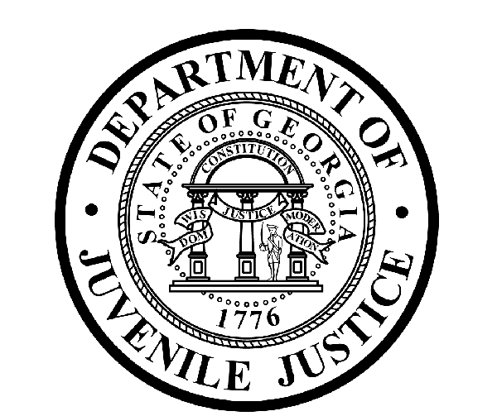

Avery D. Niles, CommissionerDepartment of Juvenile Justice

Jim Shuler, Director3408 Covington Highway ▪ Decatur, Georgia ▪ 30032-1513
Office of CommunicationsTelephone: (404) 508-7147 ▪ Fax: (404) 508-7341
FOR IMMEDIATE RELEASE CONTACT:
Jim Shuler, Director
March 18, 2013 DJJ Communications
(404) 508-7238
JimShuler@djj.state.ga.us

NEW ASSISTANT COMMISSIONER CHOSEN FOR GA DEPARTMENT OF JUVENILE JUSTICE

(ATLANTA - GA) The Commissioner of the Georgia Department of Juvenile Justice is pleased to announce his selection for the Commissioner’s top executive staff spot at DJJ Central Office. Today DJJ Commissioner Avery D. Niles named J. Mark Sexton of Lawrenceville, Georgia as the agency’s new Assistant Commissioner.

Commissioner Niles welcomed Mr. Sexton and commended him for the extensive strategic planning and change management experience he brings to bear as DJJ prepares to meet the requirements of new juvenile justice reform legislation.

“Mark Sexton’s professional skill set is built on re-evaluating and re-engineering large operations,” said Commissioner Avery Niles. “He brings the kind of leadership this agency needs for reorganizing the department, developing its real strengths, and improving its deficiencies. With his dual qualifications in emergency management and response, and strategic analysis and planning, we hope to restructure an agency that is safer and more secure, more productive, and more operationally efficient,” the Commissioner said.

The Commissioner’s choice for Assistant Commissioner comes to DJJ from the Centers for Disease Control where as a consulting contractor Mr. Sexton was an Exercise Planner and Public Health Advisor. Sexton was responsible for ensuring all aspects of a CDC exercise scenario conformed to Homeland Security Exercise and Evaluation Program guidelines and for coordinating with multiple federal agencies and public health organizations.

(MORE MORE MORE)

(PAGE TWO)

As DJJ’s new Assistant Commissioner, Sexton will draw upon his military career experience as a retired U.S. Army Lt. Colonel, with more than twenty years as a commissioned officer. He served as Chief Plans Officer and Chief of Aviation with the First Army at Ft. Gilem, GA; Chief of War Plans with the Third Army, Ft. McPherson, GA; Aide de Camp to Commanding General – Third Army, Kuwait; and Operations Officer with the 82nd Airborne in Afghanistan. He was awarded the Legion of Merit, Bronze Star, and Air medal for his military service.

“We support Governor Nathan Deal’s statewide “Hire a Georgia Veteran” campaign,” said Commissioner Niles. “At DJJ we proudly signed the pledge to provide enhanced hiring opportunities to Veterans. Lt. Colonel Sexton (Ret.) has served his country and now we look forward to serving the State of Georgia together with him at DJJ”.

Sexton has a Bachelor of Business Administration Degree from North Georgia College, and a Masters of Business Administration in Aviation with a 4.0 GPA from Embry Riddle Aeronautical. He graduated from the Command and General Staff College at Ft. Leavenworth, Kansas and the U.S Army Flight School at Ft. Rucker, Alabama.

“I have no doubt that Assistant Commissioner Sexton will benefit from his assignments in key military posts to help bring the kind of reorganization and restructure I envision for DJJ Central Office operations,” said Commissioner Niles. “As Assistant Commissioner, I expect him to implement efficient new policies and procedures at Central Office and consistently oversee change management in our secure facilities and court service offices.”

“With his Operational Planner and Management background, the new Assistant Commissioner has directed specialized work forces, streamlined organizations, increased productivity and produced outstanding safety records,” said Commissioner Niles. “We will expect Mr. Sexton to help deliver those same outstanding results for the Department of Juvenile Justice.”

Commissioner Niles congratulated DJJ’s new Assistant Commissioner and challenged him to help the agency achieve its mission to protect and serve the citizens of Georgia while assisting young offenders in becoming productive and law-abiding citizens. “One Team” – “One Mission”, said Commissioner Niles.

(END RELEASE)

