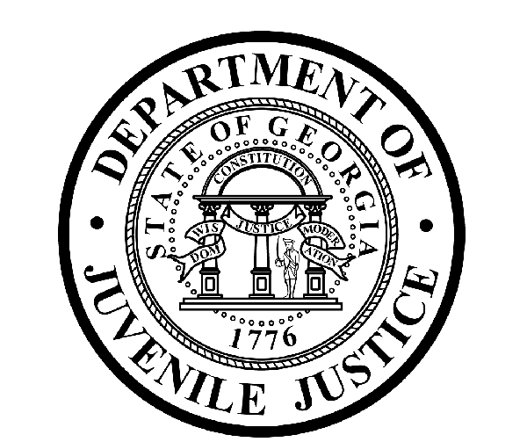

Avery D. Niles, CommissionerDepartment of Juvenile Justice

Scott Mall3408 Covington Highway ▪ Decatur, Georgia ▪ 30032-1513
Office of CommunicationsTelephone: (404) 508-7147 ▪ Fax: (404) 508-7341
FOR IMMEDIATE RELEASE CONTACT:
Jim Shuler
November 7, 2016 DJJ Communications
(404) 508-7147
JimShuler@djj.state.ga.us

DJJ Conducting ‘Veteran-Friendly’ Recruiting Campaign
Department of Juvenile Justice Honors Georgia Veterans in November

(STATEWIDE - GA) This month Department of Juvenile Justice (DJJ) Commissioner Avery D. Niles is extending his personal invitation to United States veterans to consider a juvenile corrections career with the State of Georgia. In keeping with the November 11th Veterans Day observance, Commissioner Niles is reminding veterans about Governor Nathan Deal’s “Hire a Georgia Veteran” initiative and making DJJ job offers with incentives for Georgia’s vets.

The department is filling professional positions for Juvenile Corrections Officers (JCOs), highly qualified teachers and Registered Nurses (RNs). The agency is offering employment opportunities at secure facilities throughout Georgia’s statewide juvenile justice system.

“DJJ proudly signed the ‘Governor’s Pledge to Support Georgia’s Veterans,’” said Commissioner Niles. “And we’re providing full-time employment opportunities for our veterans. That means DJJ is offering special Military Salary Increased Incentives to current and former armed services members who have active duty records,” the Commissioner said.

Governor Deal’s “Hire a Georgia Veteran” campaign is a statewide initiative to ensure veterans can transition smoothly into Georgia’s civilian workforce. The Department of Juvenile Justice actively recruits veterans as top-tier career candidates because of the special skills and exceptional experience they bring to the workforce. Some DJJ job fairs are targeted specifically to generate candidates who are veterans.

“This campaign isn’t just for one holiday in November,” said Niles. “Every day and every month, DJJ is committed to hire veterans. We’re searching for those motivated applicants who can draw on their military training to communicate the importance of leadership, respect and chain of command,” the Commissioner said.
“We need experienced men and women with armed forces backgrounds who thrive in a structured environment, who are role models for comradeship and principles, and who can promote a personal code of honor and ethics,” said Niles.

To qualify, service members must have an Honorable Discharge. The one-time incentive is based upon the current number of active duty years served.

Military Salary Increase Incentive Amounts:
- 2.5% for 1 year of active duty service
- 5.0% for 2 years of active duty service
- 7.5% for 3 years of active duty service
- 10.0% for 4+ years of active duty service

Eligible DJJ juvenile corrections job titles include Juvenile Corrections Officer 1 & 2 (JCO 1 & 2), Sergeant, Lieutenant, Captain and Juvenile Probation Parole Specialist 2 (JPPS 2). For more information on eligible job titles and required documentation, former military service members should visit the DJJ recruiting site at “DJJ Careers for Veterans.” Read more about this exciting one-time Military Salary Increase Incentive at www.djjcareers.org/ .

A juvenile corrections career is designed to help bring meaning and structure to Georgia’s challenged youth. “We want to add to our ranks with mature, responsible veterans willing to put their personal drive and specialty experience to work with our dedicated team,” the Commissioner said.

“At DJJ we’re glad to have you home. And as Commissioner of the Department of Juvenile Justice, I personally invite you to look into a State of Georgia juvenile corrections career. Come see us about a job wherever you live in Georgia. Then come join our Team!”

# # #

The Georgia Department of Juvenile Justice (DJJ) is a multi-faceted agency that serves the needs of this state`s young offenders up to the age of 21. The Department employs more than 4,000 men and women at 26 secure facilities and 92 community services offices throughout the state to effect justice and redirect the young lives in the agency`s care.

Including those who are placed on probation, more than 50,000 youths are diverted each year to evidence-based community programs, sentenced to short-term incarceration or committed to the Department`s long-term custody by the Juvenile Courts. It is the duty of DJJ’s professional corrections staff to preserve public safety and safeguard the citizens of Georgia, as well as protect the victims of crimes so that they can rebuild their lives.

At the same time, DJJ holds juvenile offenders accountable for their delinquent conduct so that they can take responsibility for their actions through probation, supervision and secure detention. The youth are provided with medical and psychological treatment, as well as specialized education and programs designed to equip them with the social, intellectual and emotional tools needed to achieve their successful reentry and reintegration into community, workplace and neighborhood settings as more productive and law-abiding citizens.

