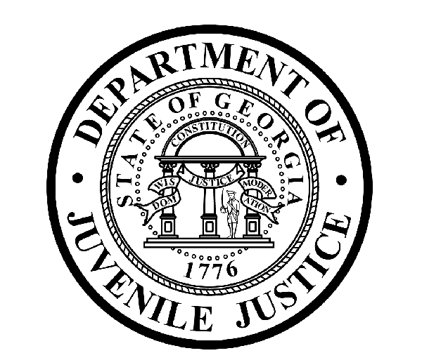

Avery D. Niles, CommissionerDepartment of Juvenile Justice

Jim Shuler, Director3408 Covington Highway ▪ Decatur, Georgia ▪ 30032-1513
Office of CommunicationsTelephone: (404) 508-7147 ▪ Fax: (404) 508-7341
FOR IMMEDIATE RELEASE CONTACT:
Jim Shuler, Director
August 9, 2013 DJJ Communications
(404) 508-7238
JimShuler@djj.state.ga.us

DJJ COMMISSIONER PLANNING STATEWIDE “KNOW THE LAW” TEEN FORUMS

(GAINESVILLE - GA) “Do You Know the Law?” That’s the question juvenile justice Commissioner Avery D. Niles wants to ask Georgia teens from Valdosta to Augusta this year as he plans a series of captivating teen forums around the state.

The Commissioner’s “Know the Law” forums are designed to educate students from twelve to twenty-one about the importance of acting correctly in the presence of law enforcement, about hanging out with the right friends, about making responsible choices every day, and about anticipating the kind of consequences to expect from reckless teen actions.

“My hope is teens everywhere will embrace the law, know what the law is, and know how the law applies to them,” Commissioner Niles said. “If all they know is what they’ve seen in movies or video games, there’s a serious reality crash headed their way and then it’s too late.”

The Commissioner’s forums focus on educating teen audiences about the law through conversations with local police chiefs, sheriff’s, prosecutors and judges. The professionals on these panels talk about what not to do on school campuses, and what teens need to know now to keep them away from trouble, and out of Georgia’s juvenile justice system.

“Education is still the key for many youth who are just another misdemeanor away from a parole violation that can lock them up in juvenile detention for months,” said Commissioner Niles. “Educating our young people about how the law applies to them and then intervening with new opportunities can reduce the chances of many of our youth becoming juvenile offenders."
With attendance from local churches, youth groups, and area schools, Commissioner Niles launched his first “Know the Law” teen forum this summer on a Wednesday evening in Gainesville, Georgia. The event drew more than 150 local students to the University of North Georgia’s Oakwood campus.

“Our goal is to draw out any young people at-risk, get them involved, discuss these issues and get them informed,” said Niles. “Our goal is about acting pro-actively, not re-actively in our communities.”
(PAGE TWO)

A familiar panel of local criminal justice experts fielded questions from the audience, spoke frankly, and offered some serious advice. The Hall County Sheriff, two Hall County Juvenile Court Judges, a Gainesville Police Major and a former youth detainee joined Commissioner Niles to cover topics from marijuana and misconduct on campus, to felonies and fake I-D’s.

The Judges answered questions ranging from teen sex and the law to misdemeanors and military service. In their discussion about juvenile records the panel also talked about which teens may get protection under juvenile laws and which teens may get prosecuted in the juvenile courts.

Commissioner Niles said this Hall County teen forum was also a great test run for what he hopes will become the successful blueprint for his long range plan to conduct many more teen forums across the state. The Department of Juvenile Justice maintains 28 juvenile detention centers in Georgia. Niles has set a personal goal to hold a teen forum in each of those host communities where DJJ runs a secure facility.

“We want to remind our youth that even as teens, their lives can present meaningful choices with significant consequences,” said Niles. “If they make positive choices now, they won’t have to face the negative consequences of having the professionals from our panels making crucial decisions that can affect their lives for years to come.”

“These face- to- face forums are a proven format for reaching out to at-risk youth in our communities,” Commissioner Niles said. “It’s so much simpler to have these conversations with our young people now, before the criminal life can find them. It’s immeasurably harder to break through to them after they get into serious trouble.”

“So whether we have standing room- only crowds at our next forum or if we only reach one or two young people at a time, it’s time well spent if we can help keep the population count down in Georgia’s juvenile justice system,” said Niles.

To see photos and coverage of the Gainesville – Hall County teen forum, visit us at this link:
http://www.djjnewsandviews.org/doyouknow13/ . The DJJ Commissioner will announce the date and location of his next “Know the Law” teen forum on the Department of Juvenile Justice “News & Views” webpage at http://www.djjnewsandviews.org/ .

(END RELEASE)

