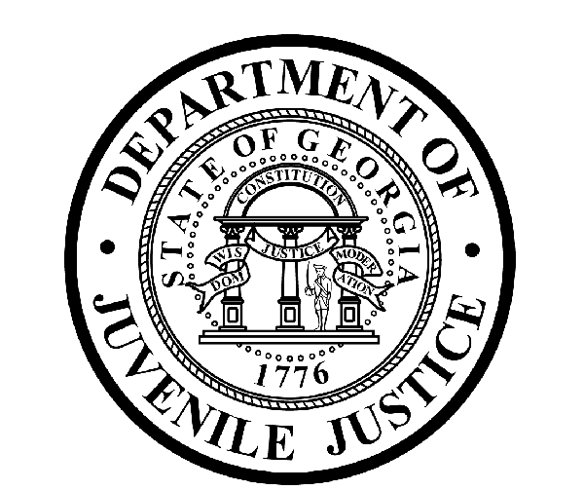

Avery D. Niles, CommissionerDepartment of Juvenile Justice

Jim Shuler, Director3408 Covington Highway ▪ Decatur, Georgia ▪ 30032-1513
Office of CommunicationsTelephone: (404) 508-7147 ▪ Fax: (404) 508-7341
FOR IMMEDIATE RELEASE CONTACT:
Jim Shuler, Director
March 19, 2015 DJJ Communications
(404) 508-7238
JimShuler@djj.state.ga.us

Department of Juvenile Justice Hiring in March
Recruiters Looking for Corrections Officer Candidates
Dublin, Vidalia, Alamo & Dawson

(STATEWIDE - GA) Several job fairs are scheduled on DJJ’s recruitment calendar this month in Dublin, Vidalia, Alamo and Dawson, Georgia. Georgia’s Juvenile Justice Commissioner Avery D. Niles says DJJ continues to seek veterans and other highly qualified candidates for new Juvenile Corrections Officer (JCO) employment opportunities now available at Georgia juvenile justice facilities throughout the state.

“We’re hiring mature, responsible adults interested in helping young offenders through troubled life transitions,” said Commissioner Avery Niles. "Serious applicants should know these juvenile corrections positions require professional attitudes and performance. It takes especially motivated people to join our mission in a full time juvenile corrections career," Niles said.

*Please note career fair locations and times may change OR additional career fair dates may be added to our recruiting schedule. Applicants should check the DJJ website for late-breaking schedule changes at www.djjcareers.org BEFORE visiting a DJJ job fair.

Date: Thursday, March 19th – GENERAL PUBLIC
Dublin DJJ Job Fair
910 North Jefferson Street
Dublin, GA 31021
Time: 10:00 AM – 3:00 PM

Date: Tuesday, March 24th – GENERAL PUBLIC
Vidalia DJJ Job Fair
Georgia Department of Labor
16 Carter Center, Queen Street
Vidalia, GA 30474
Time: 10:00 AM – 3:00 PM
(MORE MORE MORE)

(PAGE TWO TWO TWO)

Date: Thursday, March 25th - GENERAL PUBLIC
Career Fair
Wheeler County Service Center
16 W. Forest Avenue
Alamo, GA 30411
Time: 11:00 a.m. – 1:00 p.m.

Date: Thursday, March 26th - GENERAL PUBLIC
Albany RYDC Job Fair
Public Safety Complex
432 Crawford Street NE
Dawson, GA 39842
Time: 10:00 a.m. - 3:00 p.m.

In order to progress through the interview process for Juvenile Corrections Officers, candidates should bring copies of the following:
- Compass Scores (Reading 70 Writing 32)**
- SAT Scores (Verbal: 430 Math: 400) or ACT Scores (Verbal: 18 Math:16)**
- Valid Driver License
- Birth Certificate
- High School Diploma or GED
- DD214 Long Form with discharge indicated
- Naturalization Forms if NON-US Citizen
- If P.O.S.T. Certified, (Please bring two (2) forms of Gov. issued ID & P.O.S.T. Profile)

** If the applicant has a 4-year degree from an accredited college they are exempt from having to take the Compass test or provide proof of acceptable ACT or SAT scores.

DJJ recruiters are authorized to interview qualified candidates on-the-spot for new correctional officer opportunities. Applicants should bring their resumes and come dressed for job interviews. All job seekers can click on www.djjcareers.org for more information about career opportunities in juvenile corrections.

Former military service members with Honorable Discharge should click on www.djjcareers.org to learn about DJJ's one-time Military Salary Increase Incentive on eligible job titles at “DJJ Careers for Veterans”. There is no charge for participation at juvenile corrections career fairs.

**Please note that career fair times and locations may change and additional career fair dates may be added to our recruiting schedule. Applicants should check the DJJ website for late-breaking schedule changes at http://www.djjnewsandviews.org/djjcareers/ before visiting a job fair.

(END RELEASE)

