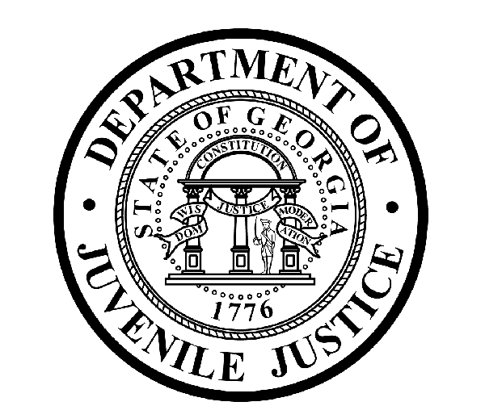

Avery D. Niles, CommissionerDepartment of Juvenile Justice

Jim Shuler, Director3408 Covington Highway ▪ Decatur, Georgia ▪ 30032-1513
Office of CommunicationsTelephone: (404) 508-7147 ▪ Fax: (404) 508-7341
FOR IMMEDIATE RELEASE CONTACT:
Jim Shuler, Director
May 04, 2015 DJJ Communications
(404) 508-7238
JimShuler@djj.state.ga.us

Dept of Juvenile Justice Honors Top 4 Juvenile Incentive Courts
Commissioner Avery D. Niles Presents Commendations from Governor

(Jekyll Island, GA) – Georgia Juvenile Justice Commissioner Avery D. Niles is pleased to announce the presentation of commendations to four Juvenile Incentive Courts today. Commissioner Niles said the commendations were made in recognition of the significant reductions in juvenile offender commitments to DJJ by those courts and for the courts’ usage of alternative community options.

“This special commendation was designed to bring distinctive recognition to the top four Juvenile Incentive Courts that achieved these goals as part of their dedication to Georgia’s juvenile justice reform mission,” said Commissioner Niles. The Commissioner made the presentations on behalf of Governor Nathan Deal at the Jekyll Island Spring Meeting of the Council of Juvenile Court Judges.

Commissioner Niles said the dedicated courts in Bibb, Columbia, Chatham and Lowndes Counties continue to apply innovative solutions to Georgia’s complex juvenile justice tasks and requirements.

The Governor’s commendations recognized the top four participating Juvenile Incentive Courts for:
1) Meeting and exceeding all program outcomes & requirements in the Juvenile Justice Incentive Grant Program;
2) Exhibiting exemplary records while achieving the Incentive Grant Program goals by appropriately placing youth in effective, community-based services; And
3) For protecting the public safety while preserving family relationships.

Governor Deal’s commendations named Bibb County Juvenile Court Judge Thomas Matthews and Judge Quintress Gilbert; Columbia County Juvenile Court Judge Douglas J. Flanagan; Chatham County Juvenile Court Judge LeRoy Burke III and Judge Lisa Goldwire Colbert; and Lowndes County Juvenile Court Judge James F. Council, Jr. and Judge William M. McIntosh. Commissioner Niles said the citizens of Georgia are thankful for the Court’s on-going contributions and their protection of Georgia’s children.
(END RELEASE)

