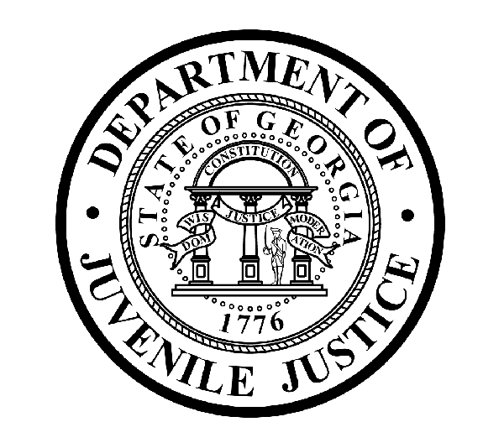
Avery D. Niles, CommissionerDepartment of Juvenile Justice

Scott Mall3408 Covington Highway ▪ Decatur, Georgia ▪ 30032-1513
Office of CommunicationsTelephone: (404) 508-7147 ▪ Fax: (404) 508-7341
FOR IMMEDIATE RELEASE CONTACT:
Matt Montgomery
SEPTEMBER 1, 2016 DJJ Communications
(404) 508-7142
matthewmontgomery@djj.state.ga.us

Department of Juvenile Justice Prepares for Hurricane Hermine
Commissioner Niles Orders Storm Preparations as Governor Declares
State of Emergency

(STATEWIDE - GA) A team of more than 4,000 state juvenile corrections professionals was busy making behind-the-scenes preparations at Department of Juvenile Justice (DJJ) secure facilities throughout Georgia Thursday, following Governor Nathan Deal’s declaration of a state of emergency due to the potential impact of Hurricane Hermine. DJJ Commissioner Avery D. Niles issued statewide orders for his agency to prepare for the potential interruption of essential services in the event that the storm causes weather-related problems at departmental facilities.

The intensifying storm led to weather alerts across southern Georgia; Governor Deal declared the state of emergency to help prepare for projected high winds, heavy rains and possible flash flood damage in 56 counties.

DJJ safety officers began checking emergency weather preparations at six short-term Regional Youth Detention Centers (RYDCs) and two long-term Youth Development Campuses (YDCs) that may lie in the storm’s path. Preparation has been underway at Loftiss RYDC in Thomas County, Waycross RYDC in Ware County, Crisp RYDC in Crisp County, Eastman YDC and RYDC in Dodge County, Milan YDC in Telfair County, Claxton RYDC in Evans County and Savannah RYDC in Chatham County.

Commissioner Niles said, “It is reassuring to know Governor Deal’s executive order is already in place. We have been working to ensure the safety of our youth and staff in these secure juvenile facilities in case the storm moves through Georgia as predicted.” Back-up power generators were being tested and fuel tank levels were being checked at DJJ secure facilities throughout the state in anticipation of possible power outages.

DJJ operates an Office of Planning and Preparedness, especially created to maintain readiness for inclement weather events like this storm. With professional guidance from a career public safety expert, DJJ maintains constant contact with both the Georgia Emergency Management & Homeland Security Agency and the National Weather Service to monitor ongoing emergency conditions.

DJJ’s Planning and Preparedness Director has also been reviewing emergency policy and procedures with facility directors and coordinating inventories of emergency equipment and supplies, as well as checking on statewide positioning of agency transportation units in case there is a need for the activation of evacuation strategies. As part of these contingency plans, other DJJ secure facilities around the state are designated to receive evacuated DJJ youth and are placed on stand-by until weather hazards have passed.

As a general safety precaution due to weather-related driving hazards encountered by teaching staff, DJJ often cancels its own daily education classes to coordinate with public school systems in surrounding affected counties. However, the Department makes every effort to ensure that appropriate staffing levels of essential POST-certified juvenile corrections officers maintain watch at DJJ secure facilities during all emergency events. The current state of emergency extends through midnight Saturday.

###

