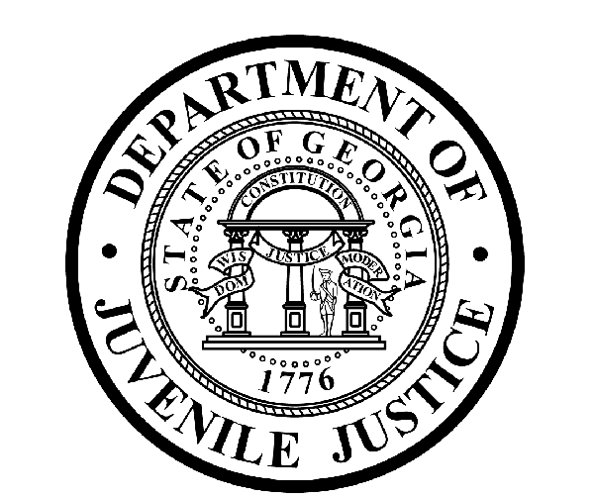

Avery D. Niles, CommissionerDepartment of Juvenile Justice

Jim Shuler, Director3408 Covington Highway ▪ Decatur, Georgia ▪ 30032-1513
Office of CommunicationsTelephone: (404) 508-7147 ▪ Fax: (404) 508-7341
FOR IMMEDIATE RELEASE CONTACT:
Jim Shuler, Director
June 6, 2013 DJJ Communications
(404) 508-7238
JimShuler@djj.state.ga.us

How Georgia Built a New ‘Reporting Culture’ Among its Youth in Custody:
Encouraging Juvenile Offenders to Report Sexual Victimization

(ATLANTA - GA) When the Justice Department’s Bureau of Justice Statistics released the results of its 2012 National Survey of Youth in Custody this week, the Georgia Department of Juvenile Justice was ranked as one of four states with an overall sexual victimization rate that exceeded 15-percent. The Georgia data was based on survey questions answered by youth in custody at several DJJ detention facilities. The Department of Justice defines sexual victimization as “any unwanted sexual activity between youth and all sexual activity between youth and staff”.

Georgia Department of Juvenile Justice administrators know these DOJ surveys are required annually in keeping with the federal Prison Rape Elimination Act, known in Corrections as P.R.E.A. – (pronounced PREE-AH). So every year, Georgia DJJ encourages its juvenile population to freely participate and honestly respond to the federal survey questions as part of this agency’s policy of public transparency.

DJJ Commissioner Avery D. Niles indicates juvenile justice officials here were expecting an increased number of survey responses to come from Georgia’s incarcerated youth this year, because Georgia has launched one of the most proactive youth education PREA programs in the country to teach its youth in custody how to stay alert and report PREA abuses.

“Through education and awareness, Georgia is building a new “reporting culture” among our youth in custody so our residents won’t be intimidated about seeking help if they should ever encounter these types of abuses, whether it’s inside or outside our secure facilities,” said Commissioner Niles. “We want them to know it’s OK to break the silence. We want them to speak up, speak out, and say ‘NO’ to sexual abuse.”

(MORE MORE MORE)

(PAGE TWO)
“We have a Zero Tolerance policy in Georgia for PREA violations,” Niles said. “Having a PREA ‘Zero Tolerance’ policy ensures that our youth know these rules are strictly enforced -- And that staff is aware they’re responsible for the safety of youth in DJJ custody. We start by teaching our new arrivals about reporting sexual abuse and harassment from the day they walk in our doors,” the Commissioner said.
Within 24 hours of starting their intake process new residents receive age-appropriate PREA flyers and safety guides describing their rights and how to report incidents or suspicions of violations. DJJ instructs all residents about the right to file grievances against any inappropriate conditions, behaviors, or actions of staff or other residents. Youth are shown where to deposit their grievance in the Director’s locked box. All residents watch a PREA Orientation message personally videotaped by the Commissioner. Afterward they’re required to sign a Youth PREA Acknowledgement Statement.
Commissioner Niles predicts DJJ’s strict implementation of these policies will most likely result in even more DOJ youth survey participation in the future. The Commissioner hopes that in the best case scenario, DJJ youth will also report PREA violations for timely investigation and prosecution by the Department of Juvenile Justice. The agency’s Office of Investigations is responsible for the official investigation of all allegations of sexual abuse. DJJ engages assistance from the Georgia Bureau of Investigation for many of these cases.

DJJ also initiated an Intelligence Tipline to provide youth in the community, staff in the facilities, and the general public with a method for making third-party reports of sexual abuse, sexual harassment, or youth or staff seeking relief against any retaliation for reporting. DJJ honors all anonymous third-party reporting.

DJJ’s education and investigation elements are just two reasons Georgia is considered a national leader in the PREA program integration process. The PREA webpage operated on the Department of Juvenile Justice website at www.djjnewsandviews.org/preageorgia is one of the top-visited corrections policy subject matter sites in Georgia. Currently rated as the second highest ranked site on Google, Yahoo and Bing search engines for the term “Georgia PREA”,
DJJ’s web-based information center has proved to be an invaluable resource for juvenile justice researchers and corrections facilities across the state and throughout the country.

DJJ hired its first statewide PREA Coordinator in March 2012, two months before DOJ released their final PREA standard in May. Today, a DJJ PREA Advisory Committee monitors all Georgia juvenile detention centers for compliance. PREA goals are included in DJJ’s Strategic Plan. Monthly committee meetings evaluate Georgia’s PREA planning, provide technical assistance, deliver quality assurance documentation, and develop corrective action plans to address any deficits.

Beginning April 2012, all public and private agencies contracting with DJJ for the confinement of Georgia youth must include a legal obligation to adopt and comply with PREA standards as part of their new contract or contract renewal.

DJJ’s first stand-alone PREA policy was authorized in August 2012 when PREA National Standards were integrated into more than 50 pre-existing DJJ policies to ensure an overriding agency protocol for all DJJ facilities, residential programs and court service offices.

“Now, as of February 2013, more than 65-hundred Georgia juvenile justice staff members, volunteers, contractors, and interns have completed DJJ’s new PREA training based on their level of contact with DJJ youth,” said Commissioner Niles. “Our facility staff is trained to understand the crucial nature of enforcing detailed PREA standards in secure facilities.”
(PAGE THREE)

Many of Georgia’s existing facility ‘accountability systems’ such as Closed Circuit Television monitoring, incident reporting and counseling services were already functioning within PREA guidelines to help ensure the safety and security of youth in DJJ secure facilities.
A DJJ Safety and Security Task Force labeled areas to be kept locked and monitored. CCTV camera blind spots were identified and managed by repositioning cameras and corrections officer posts. Other PREA safety adaptations required special PREA doors to be ordered with windows to allow direct line of sight into offices and rooms.

“We welcome the implementation of these PREA requirements as innovations in agency culture change that will accompany the scheduled restructuring and improvements under Georgia’s new Juvenile Justice Reform Act,” said Commissioner Niles. “In many ways the PREA Zero Tolerance policy against sexual abuse and sexual harassment aligns with my own Top Priority for DJJ: To Operate Safe and Secure Facilities and Communities,” said Niles. “In keeping with this agency’s policy of public transparency, Georgia will continue to encourage our youth in custody to respond to these federal survey questions. DJJ will always teach them to break the silence and say ‘NO’ to sexual abuse.”

“The DOJ National Survey of Youth in Custody reminds us why we have invested so much effort in solutions to correct these challenges and to ensure a sexually safe environment for our youth in the care and custody of the Georgia Department of Juvenile Justice,” Niles said. “I thank more than 4,000 professional staff members working at DJJ centers and offices across the state as we face this task of PREA implementation and Georgia juvenile justice reform together,” said Commissioner Niles. “One Team - One Mission.”

(END RELEASE)

