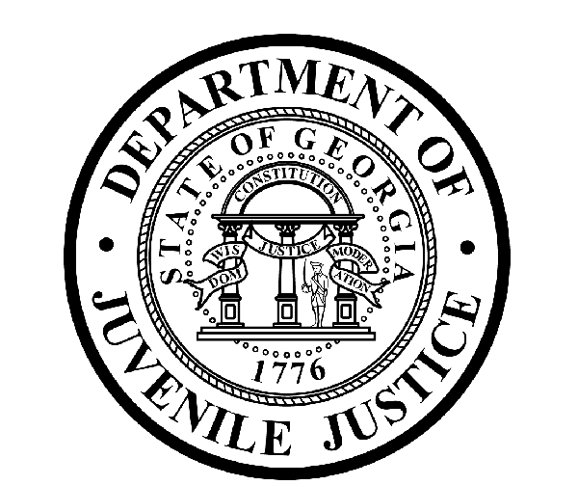

Avery D. Niles, CommissionerDepartment of Juvenile Justice

Jim Shuler, Director3408 Covington Highway ▪ Decatur, Georgia ▪ 30032-1513
Office of CommunicationsTelephone: (404) 508-7147 ▪ Fax: (404) 508-7341
FOR IMMEDIATE RELEASE CONTACT:
Jim Shuler, Director
October 10, 2014 DJJ Communications
(404) 508-7238
JimShuler@djj.state.ga.us

Georgia Preparatory Academy Celebrates ‘National School Lunch Week’
GA’s 181st School District “Gets in the Game with School Lunch” Foods and Exercise

(DECATUR, GA) – Commissioner Avery D. Niles is pleased to announce Georgia Preparatory Academy schools will “Get in the Game with School Lunch” next week, along with thirty-million school children nationwide to celebrate the National School Lunch Program.

The National School Lunch Week observance will run from October 13 through 17 to emphasize the healthy foods offered every school day at our nation’s schools. DJJ will feature events and activities at the Georgia Preparatory Academy to promote the importance of balancing healthy eating with physical activity and exercise.

“Our goal is to incorporate sports-themed menus and school activities to reinforce the benefits of nutritious meals and physical activity for our students,” said Commissioner Avery Niles. “In addition to sports-themed menu items, our game plan for the National School Lunch Program week includes a field day, a sports-themed movie night and DJJ education staff wearing their favorite sports gear.”

The “Get in the Game with School Lunch” event at the Georgia Preparatory Academy also includes an art contest, nutrition activity sheets, and a door decorating contest.

“Our school lunches are healthier than ever,” said DJJ Dietician Lauren Gean, RD, LD. Gean said meals at the Georgia Preparatory Academy have more fruits and vegetables, more whole grains and less fat and sodium.

“National School Lunch Week is the perfect time to celebrate all the healthy options we’re serving daily in the lunch rooms of Georgia’s 181st School District,” said Gean.

(MORE MORE MORE)

(PAGE TWO TWO TWO)

Through the National School Lunch Program, DJJ youth are provided meals low in sodium and rich in whole grains. The menus include a variety of fruits and vegetables, protein, and a choice of low-fat or fat-free milk.

“Our goal is to provide nutrient rich, quality meals that young people enjoy. By promoting these healthy options, youth are learning how to eat a nutritious, filling meal,” said Commissioner Niles. “Along with other essential life skills required for successful reentry into their communities, we’re helping them develop nutritional habits here that they can carry with them outside of these school lunch rooms and institutional settings and into their daily lives,” Niles said.

The federally-funded National School Lunch Program (NSLP) provides nutritionally balanced, healthy meals to students every day. The program, which has been serving this nation's children for more than 60 years, requires school meals to meet strict federal nutrition standards. The standards require serving whole-grain rich foods, offering fruits and vegetables every day, and limiting fat, calories, and sodium.

For more information about healthy foods and the benefits of nutritious schools meals at DJJ, visit http://www.djj.state.ga.us/ or www.facebook.com/TrayTalk . The “Get in the Game with School Lunch” campaign is sponsored by the non-profit School Nutrition Association.

(END RELEASE)

