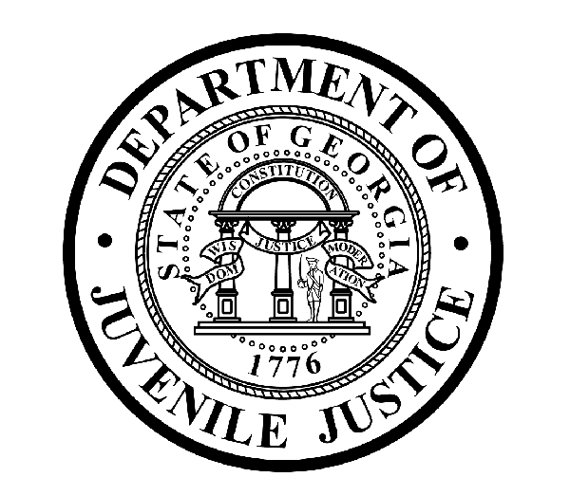

Avery D. Niles, CommissionerDepartment of Juvenile Justice

Jim Shuler, Director3408 Covington Highway ▪ Decatur, Georgia ▪ 30032-1513
Office of CommunicationsTelephone: (404) 508-7147 ▪ Fax: (404) 508-7341
FOR IMMEDIATE RELEASE CONTACT:
Jim Shuler, Director
April 23, 2013 DJJ Communications
(404) 508-7238
JimShuler@djj.state.ga.us

DJJ LEADERSHIP SELECTED TO SERVE ON GEORGIA’S JUVENILE JUSTICE INCENTIVE GRANT PROGRAM FUNDING COMMITTEE

(ATLANTA - GA) Georgia Governor Nathan Deal announced on Tuesday the appointment of Department of Juvenile Justice Commissioner Avery D. Niles and Deputy Commissioner of Community Services Carl Brown to the newly created Juvenile Justice Incentive Grant Program Funding Committee.

The Juvenile Justice Incentive Grant Program Funding Committee (JJIGPFC) was created by Governor Deal to review and fund local community programs designed to reduce youth recidivism across the state. The General Assembly recently appropriated five million dollars to help pilot a performance incentive grant program administered by the Criminal Justice Coordinating Council. JJIGPFC will work with the Criminal Justice Coordinating Council to provide guidance for the allocation of community funding to maximize public resources and reduce the expense of youth detention.

Commissioner Niles and Deputy Commissioner Brown are two of the nine appointed JJIGPFC board members which include Representative Wendell Willard and Clayton County Commissioner Chairman Jeffery Turner. Joe Hood of the Governor’s Office of Planning and Budget and Joe Vignati of the Governor’s Office for Children and Families were named as the Co-Chairmen of the Committee.

“I am honored that Governor Deal has placed his confidence in me and Deputy Commissioner Brown to be part of the inaugural group for this important committee,” said Commissioner Avery Niles. “Decisions made by this group will help strengthen local programs serving our youth and will act as a guide for future juvenile justice choices.”

The creation of the Juvenile Justice Incentive Grant Program Funding Committee is another innovation in a long line of juvenile justice reforms championed by Governor Deal and the Special Council on Criminal Justice Reform. Along with the changes brought forth by the recently passed Juvenile Justice Reform Bill (House Bill 242), it is anticipated that the JJIG Program will reinforce community-based options aimed at reducing youth recidivism in Georgia.

(END RELEASE)

