

Avery D. Niles, CommissionerDepartment of Juvenile Justice

Jim Shuler, Director3408 Covington Highway ▪ Decatur, Georgia ▪ 30032-1513
Office of CommunicationsTelephone: (404) 508-7147 ▪ Fax: (404) 508-7341
FOR IMMEDIATE RELEASE CONTACT:
Jim Shuler, Director
May 30, 2014 DJJ Communications
(404) 508-7238
JimShuler@djj.state.ga.us

DJJ FOCUS ON EDUCATION
The ABC’s of Earning GED’s and Diplomas:
Graduation Day at Georgia’s Preparatory Academy

(AUGUSTA – GA) Commissioner Avery D. Niles is proud to announce the success of another consolidated DJJ graduation ceremony, combining senior class grads from seven secure Youth Development Campuses around the state. The landmark DJJ education event at Georgia’s Augusta YDC celebrated the second combined graduation observance to be conducted by the Department of Juvenile Justice.

DJJ’s young graduates were move by security transports across Georgia for the opportunity to cross the stage together in their caps and gowns and to receive their high school diplomas and GED’s in front of a special audience that included many parents and teachers.

“These juvenile offenders presented themselves in an orderly, professional manner to march in our Georgia Preparatory Academy processional and to be part of a real graduation ceremony,” said Commissioner Niles.

DJJ Associate Superintendent of Schools Audrey Armistad reminded students this graduation was a celebration of their hard work, dedication and commitment. “Many of you seated here today may not have believed you could one day march to the music of ‘Pomp and Circumstance’ and yet, here you are!” she said. “I’m proud of you! You managed to take an unfortunate situation in your life and turn it to your advantage.”

“We wanted these students to experience the personal excitement of graduating with a large group of classmates,” said DJJ Assistant Commissioner Mark Sexton. “We wanted to create that genuine feeling of accomplishment that comes with standing up to be recognized for academic achievement and earning a degree,” Sexton said. “That’s why we put in so many extra miles to move all these students from our education centers at Youth Development Campuses around the state.”
(MORE MORE MORE)

(PAGE TWO)

AC Sexton told the candidates, “With graduation, you have set yourself above your peers at DJJ -- and above your peers in the community. Look at today’s graduation as your foundation for the start of other important goals you will accomplish in life.”

Keynote speaker, State Representative Henry “Wayne” Howard (D) from Augusta District 124, greeted the grads with his perspective on accomplishment and redemption. “Everyone has a history and a past,” Representative Howard said. “We can overcome the bad and each one of you here has the opportunity to make the best of life.”

Lee Arrendale State Prison “Voices of Hope” choir member Leshay Evans spoke to the young offenders about her own criminal background experience. “Murder at 16 years old. Conviction at 17 years old,” Leshay said. “Life is about choices. You have a chance to go out in the real world. You have a chance to start over.”

Board Member Dr. Thomas Coleman challenged the grads to accept his challenge to go out and live life. “Don’t look for miracles,” Dr. Coleman said. “Become someone’s miracle. When you do that, success will follow.”

DJJ Board Member Sandra Heath Taylor told the graduates, “People here at DJJ love you more than you know and we are so proud of your accomplishments!”

Commissioner Avery Niles made a surprise presentation of special-issue “Commissioner’s Coins” to honor Lee Arrendale State Prison Warden Kathy Seabolt for her interagency cooperation and to DJJ Associate School Superintendent, Dr. Audrey Armistad, for her twenty-five years of service to the State of Georgia.

DJJ grads from Youth Development Campuses in Muscogee, Macon, Milan, Eastman, Atlanta, Augusta, Savannah, and Sumter filed into the auditorium as candidates from Georgia’s 181st state school district. With a traditional turn of their tassels, they marched-out again as the Georgia Preparatory Academy’s Graduating Class of 2014.

In all, seventeen candidates qualified for diplomas presented by Commissioner Avery Niles from DJJ’s Georgia Preparatory Academy. Six students received GED’s, nine others earned high school diplomas, and two received transition diplomas while serving out their juvenile court orders.

At every graduation ceremony Commissioner Niles tells parents his goal is that every youth who leaves DJJ custody is a grade level or above where they ranked in school when they entered the juvenile justice system. Photos of DJJ’s graduation ceremonies are posted on the agency’s “News & Views” webpage at http://www.djjnewsandviews.org .

(END RELEASE)
The Georgia Preparatory Academy has dual accreditation from the Southern Association of Colleges and Schools (SACS) and from the Correctional Educational Association (CEA). ..The mission of the Georgia Preparatory Academy is to provide a comprehensive educational program which will facilitate the successful integration of each student into the community and workplace..
BELOW ARE PHOTOGRAPHS FROM THE DJJ 2014 SPRING GRADUATION. PHOTO ONE DEPICTS A FEMALE GRADUATE ON STAGE. IN PHOTO TWO DJJ COMMISSIONER AVERY D. NILES AWARDS A DIPLOMA TO A MALE DJJ GRADUATE. DJJ PHOTOS MAY BE USED IN NEWS PUBLICATIONS WITH PHOTO CREDIT, “Courtesy Georgia DJJ.

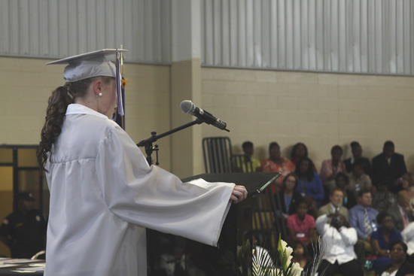
PHOTO CREDIT: GEORGIA DJJ GEORGIA PREPARATORY ACADEMY GRADUATION
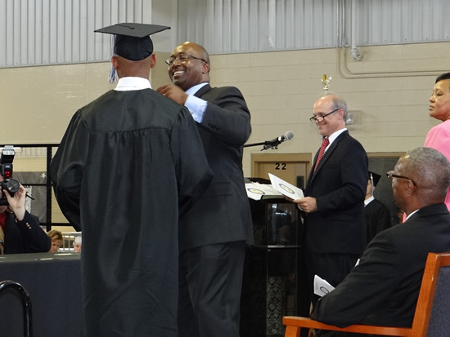
PHOTO CREDIT: GEORGIA DJJ DJJ COMMISSIONER AVERY NILES WITH A RECENT GEORGIA PREPARATORY ACADEMY GRADUATE

