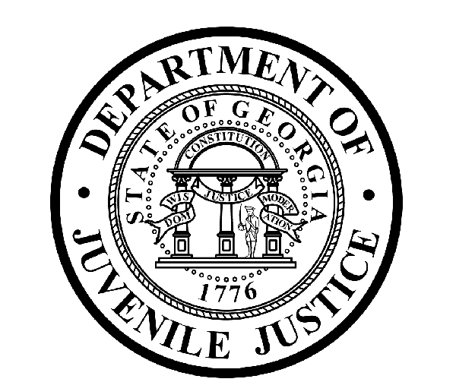

Avery D. Niles, CommissionerDepartment of Juvenile Justice

Jim Shuler, Director3408 Covington Highway ▪ Decatur, Georgia ▪ 30032-1513
Office of CommunicationsTelephone: (404) 508-7147 ▪ Fax: (404) 508-7341
FOR IMMEDIATE RELEASE CONTACT:
Jim Shuler, Director
August 26, 2015 DJJ Communications
(404) 508-7238
JimShuler@djj.state.ga.us

Department of Juvenile Justice Recruiting in AUGUST
DJJ Recruitment Fair Slated for Atlanta Technical College

(ATLANTA - GA) The Atlanta Technical College campus on Metropolitan Parkway is highlighted as the site for DJJ recruiting activities on this month’s recruitment calendar.

During the upcoming job fair on August 26th, 2015, Georgia’s Juvenile Justice Commissioner Avery D. Niles is sending teams of recruiters to seek qualified candidates to fill essential juvenile correctional officer (JCO) positions. DJJ recruiters are authorized to conduct on-the-spot interviews for qualified JCO1 candidates during a full cycle employment process that day.

Commissioner Niles says DJJ needs mature adults and professionally motivated officers who can help Georgia’s juvenile offenders make successful reentry from the juvenile justice system back to society as productive citizens.

Representatives from each DJJ Division will be on hand to speak to attendees about a full range of
meaningful employment opportunities at the Department of Juvenile Justice, including roles and requirements for teachers, nurses, behavioral health specialists, administrative professionals, food service workers and probation officers.

The Commissioner says DJJ is also on the lookout for Georgia veterans with public service know-how and chain of command experience. “DJJ is a great place to make your work count,” Commissioner Niles said.

*Please note career fair locations and times may change OR additional career fair dates may be added to our recruiting schedule. Applicants should check the DJJ website for late-breaking schedule changes at www.djjcareers.org BEFORE visiting a DJJ job fair.

( MORE MORE MORE )

(PAGE TWO TWO TWO)

The August Recruitment Fair schedule is below.
Date: Wednesday, August 26th, 2015
Time: 9:00AM - 11:00 AM ATC STUDENTS ONLY
Time: 11:00AM - 1:00PM GENERAL PUBLIC & ATC STUDENTS
Atlanta Technical College
1560 Metropolitan Parkway, SW.
Atlanta, GA. 30310
Academic Complex, Building C

Applicants for Juvenile Correctional Officer should come dressed for job interviews with their resumes ready. All job seekers can click on www.djjcareers.org for more information about career opportunities in juvenile corrections. In order to progress smoothly through the Juvenile Correctional Officer interview process, candidates should bring the following:

- Copy - Birth Certificate
- Copy - High School Diploma or GED
- Copy - Valid Driver License - State issued ID
- Copy - Social Security Card
- Copy - Compass Test Scores, SAT Scores or ACT Scores
- Copy - P.O.S.T. Profile for Certified Officers

** If applicants have a 4-year degree from an accredited college they are exempt from taking the Compass test or providing proof of acceptable ACT or SAT scores.

Former military service members with Honorable Discharge should click on www.djjcareers.org to learn about DJJ's one-time Military Salary Increase Incentive on eligible job titles at “DJJ Careers for Veterans”. Join us online to discover all the job opportunities available at the Department of Juvenile Justice. There is no charge for participation at juvenile corrections career fairs.

**Please note that career fair times and locations may change and additional career fair dates may be added to our recruiting schedule. Applicants should check the DJJ website for late-breaking schedule changes at http://www.djjnewsandviews.org/djjcareers/ before visiting a job fair.

(END RELEASE)

“DJJ is a great place to make your work count.”
Avery D. Niles, Commissioner
Georgia Department of Juvenile Justice

“The Department of Juvenile Justice is an Equal Opportunity Employer”

