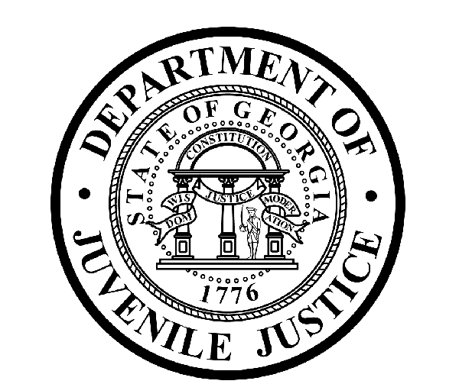

Avery D. Niles, CommissionerDepartment of Juvenile Justice

Jim Shuler, Director3408 Covington Highway ▪ Decatur, Georgia ▪ 30032-1513
Office of CommunicationsTelephone: (404) 508-7147 ▪ Fax: (404) 508-7341
FOR IMMEDIATE RELEASE CONTACT:

April 5, 2013 DJJ Communications
(404) 508-7238

MARIETTA RYDC OFFICER ARRESTED ON FELONY DRUG CHARGES

(Polk County - GA) Commissioner Avery D. Niles of the Georgia Department of Juvenile Justice announced today that Polk County Sheriff’s Deputies have arrested off-duty juvenile corrections officer (JCO) Craig Banks on felony drug charges. Narcotics investigators notified DJJ Internal Affairs the arrest was made in connection with a two-year sting operation targeting Banks for the alleged sale of marijuana. Their investigation continues at this time.

According to local police investigators Banks was taken into custody Thursday afternoon and booked into the Polk County Jail where he is currently being held on misdemeanor charges of Marijuana Possession, and felony charges of Possession of Marijuana with Intent to Distribute and Possession of a Firearm During the Commission of a Crime.

Following the arrest, DJJ Commissioner Avery Niles announced he would order immediate administrative action for the suspension of JCO Banks from all duties at the Department of Juvenile Justice. Before his suspension today, Banks was posted as a juvenile corrections officer at the Marietta Regional Youth Detention Center (RYDC) in Cobb County.

The Commissioner said an immediate DJJ internal affairs check into all incidents reported at the Marietta RYDC revealed no contraband cases involving the Juvenile Corrections Officer. The Commissioner also said there was no other evidence to indicate Banks may have moved contraband into the state detention facility where he worked.

Commissioner Niles, who endorses agency transparency like the public reporting of today’s arrest said, “This officer has been with the department for nearly ten years. But regardless of employee seniority, rank or position, those who break our laws and those who violate our policies will continue to face serious consequences and DJJ will continue to cooperate with prosecuting authorities. I gave clear warning of this when I was appointed Commissioner,” said Niles.

(MORE MORE MORE)

(PAGE TWO)

The Commissioner’s’ core message since his November 2012 appointment by Governor Nathan Deal has emphasized that the critical duties of the Department of Juvenile Justice are to uphold and enforce policy, ethics, and safety and security measures at Georgia’s juvenile justice facilities so both DJJ detainees and staff can function in a safe and secure learning environment.

A booking photograph of Craig Banks is attached at the end of this news release.

(END RELEASE)

DJJ DISCLAIMER: “Information regarding this arrest is public record and was obtained from area law enforcement agencies. All suspects are presumed innocent until found guilty in a court of law.”

