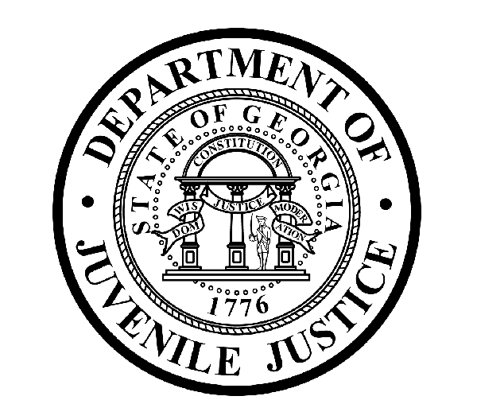

Avery D. Niles, CommissionerDepartment of Juvenile Justice

Jim Shuler, Director3408 Covington Highway ▪ Decatur, Georgia ▪ 30032-1513
Office of CommunicationsTelephone: (404) 508-7147 ▪ Fax: (404) 508-7341
FOR IMMEDIATE RELEASE CONTACT:
Jim Shuler, Director
July 16, 2013 DJJ Communications
(404) 508-7238
JimShuler@djj.state.ga.us

Commissioner: ‘Seven Officers Removed from DeKalb RYDC Duty’
Entire Night Shift Investigated for Security Violations

(ATLANTA - GA) Today, Department of Juvenile Justice Commissioner Avery D. Niles announced the conclusion of a three-week investigation into safety and security violations at DJJ’s DeKalb Regional Youth Detention Center. The investigation resulted in the entire overnight security staff being removed from duty at the RYDC. Six corrections officers and their supervisor were suspended with pay while the investigation was being conducted.

Three Resigned.. Four Dismissed..
Three of the juvenile corrections officers who were accused, including the shift sergeant, resigned their posts while their reviews were still underway. The four remaining officers were all dismissed.

“The shift supervisor and several of these night shift officers actually watched the youths enter and exit the detention center housing units at-will and without staff supervision after lights-out,” Commissioner Avery Niles said. “This level of disregard for DJJ Safety and Security Policy is intolerable. We expect our corrections staff to strictly enforce our security policies as a priority of their daily duties,” said Commissioner Niles.

DJJ Officers Entrusted with Safety & Security..
“Our officers are entrusted with ensuring our youth receive their meals, health care and education in a secure environment so they can successfully transition back to schools or employment in their community,” the Commissioner said. “This incident is truly an anomaly that in no way fairly reflects the extraordinary efforts of more than four-thousand DJJ employees who meet the daily demands and deadlines that keep Georgia’s juvenile justice system working around the state.”

(MORE MORE MORE)

(PAGE TWO)

The DJJ Commissioner said the investigation of the seven RYDC night shift officers was the result of evidence brought to light by Department of Corrections Investigators working with DJJ in the course of an unrelated case reported at the DeKalb youth detention facility.

The Commissioner said the investigation focused on allegations of misconduct on the job, deficiencies in accountability, and violations of policies meant to safeguard the integrity of the department.

“The DOC Investigators determined the case they were originally assigned at DeKalb RYDC was unfounded and unsubstantiated,” said Commissioner Niles. “But by being alert and thorough in their observations, the investigations team uncovered evidence of a night shift staff security problem which required immediate examination.”

Governor’s Mandate for DJJ Reform..
Commissioner Niles said, “The Governor gave me a mandate to reform and reorganize this agency when I was appointed. Every time we launch an investigation like this, our underlying goal is to reshape this agency into one of the nations’ best. We will continue to work on improving any outdated performance within this department,” said Commissioner Niles. “Our employees deserve it and our state demands it.”

The Commissioner thanked the Department of Corrections for assisting with ongoing DJJ investigations while his department is still conducting a major internal review.

“It should be obvious to all agency personnel that DJJ has the capability of conducting more than one major investigation at a time and to take swift action against staff misconduct and egregious policy violations like this,” said Commissioner Niles.

All DJJ youth were accounted for at the DeKalb RYDC. A replacement corrections staff was immediately assigned. There were no incidents and no injuries reported as a result of the security violation.

Commissioner Will Not Tolerate Policy Violations..
“We will not tolerate policy violations like these which have the potential of breaching the security of DJJ detention facilities or compromising the safety of the youth we serve and the protection of the public,” said Commissioner Niles. “I will continue to repeat that message to our staff and I will continue to authorize employee dismissal letters until that message gets through.”

Commissioner Avery D. Niles challenged his statewide Department of Juvenile Justice staff to focus on the agency’s Top Five Priorities to consider how an incident like the one at DeKalb RYDC could have been avoided:

Commissioner’s Top Five Priorities:
- Operate Safe, Secure Facilities and Communities..
- Juvenile Justice Reform..
- Recruitment, Retention and Succession Planning..
- Classification and Placement of Youth..
- Offender / Youth Re-Entry..

(END RELEASE)

