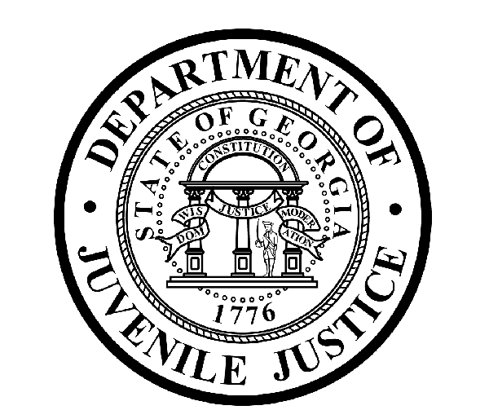

Avery D. Niles, CommissionerDepartment of Juvenile Justice

Jim Shuler, Director3408 Covington Highway ▪ Decatur, Georgia ▪ 30032-1513
Office of CommunicationsTelephone: (404) 508-7147 ▪ Fax: (404) 508-7341
FOR IMMEDIATE RELEASE CONTACT:
Jim Shuler, Director
April 15, 2013 DJJ Communications
(404) 508-7238
JimShuler@djj.state.ga.us

DJJ COMMISSIONER PICKS NEW CFO FOR GA DEPARTMENT OF JUVENILE JUSTICE

(ATLANTA - GA) The Commissioner of the Georgia Department of Juvenile Justice is pleased to announce his selection for a top Central Office Leadership Team spot at DJJ. Today Commissioner Avery D. Niles named Sonja R. Allen of Tucker, Georgia as the agency’s new Chief Financial Officer.

Commissioner Niles welcomed CFO Allen and commended her for the extensive background in Management, Analysis and Budget Coordination she brings to DJJ. Allen has a Bachelor of Business Administration in Accounting from Tennessee State University and more than twenty years of experience in Accounting, Auditing and Budget fields.

“Sonja Allen’s professional skill set is built on sound management principles, policy coordination, team leadership and problem solving experience covering two decades in several state government agencies,” said Commissioner Avery Niles.

The Commissioner’s choice for Chief Financial Officer comes to DJJ from the Georgia Department of Public Health. As Director of Financial Services at DPH in 2011, Sonja Allen assisted that agency’s Chief Financial Officer in the formation of the new Finance Division for Georgia’s new Department of Public Health. Allen was responsible for analyzing financial information and accounting data to identify trends impacting the agency’s fiscal and cash flow positions along with budget forecasts, projections and analysis.

Prior to her service at DPH, Allen was Budget Director at the Georgia Department of Human Resources – Child Support Services division for three years. She served four years as Policy Coordinator and Analyst at the Governor’s Office of Planning and Budget (OPB). She was OPB Budget Officer for the Office of DHR four years before that. And she served as Senior Budget Analyst for the Fulton County Finance and Budget Office for three years prior to her work for DHR – OPB.
(MORE MORE MORE)

(PAGE TWO)

“I have no doubt that DJJ will benefit from Allen’s previous assignments in key state government financial services posts to help bring about the kind of positive growth and finance systems’ streamlining I envision for DJJ Central Office operations,” said Commissioner Niles. “With Allen as our new CFO, I expect to see increased financial services productivity and the delivery of more outstanding financial systems results for the Department of Juvenile Justice.”

Commissioner Niles congratulated DJJ’s new CFO and challenged her to help support the department as it achieves its mission to protect and serve the citizens of Georgia while assisting young offenders to become productive and law-abiding citizens. “One Team” – “One Mission”, said Commissioner Niles.

(END RELEASE)

