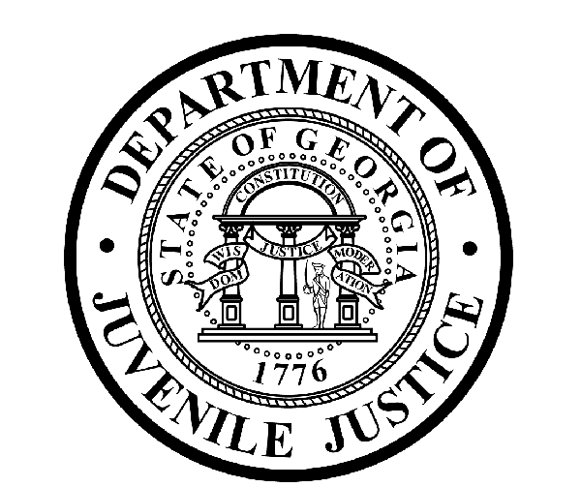

Avery D. Niles, CommissionerDepartment of Juvenile Justice

Scott Mall3408 Covington Highway ▪ Decatur, Georgia ▪ 30032-1513
Office of CommunicationsTelephone: (404) 508-7147 ▪ Fax: (404) 508-7341
FOR IMMEDIATE RELEASE CONTACT:
Jim Shuler
March 28, 2017 DJJ Communications
(404) 508-7147
JimShuler@djj.state.ga.us

Augusta YDC Hiring Corrections Officers at March 29 Career Fair

(AUGUSTA-GA) The Department of Juvenile Justice (DJJ) is recruiting full-time correctional employees for one of Georgia’s most challenging and rewarding criminal justice career areas. Commissioner Avery D. Niles has authorized agency recruiters to find qualified candidates for Juvenile Corrections Officer (JCO) positions at the Augusta Youth Development Campus (YDC).

Recruiters are seeking mature candidates to make a positive difference in the lives of Georgia’s young offenders and help prepare them to build successful lives returning to their communities.

“We’re recruiting motivated applicants to help juvenile offenders through their troubled life transitions while in secure state custody,” Commissioner Niles explained.

DJJ provides a vigorous training program for new recruits at its own certified state academy. The agency offers complete state health and benefit packages with competitive compensation for new JCOs.

“At DJJ we help construct personal launchpads for success out of landscapes of abandoned hopes,” Commissioner Niles said. “We’re looking for applicants from corrections, the military or law enforcement who can apply their knowledge and experience to find new in a structured juvenile justice environment,” the Commissioner said. Prior military experience may qualify candidates for up to an additional 10 percent in salary.

*Please note career fair locations and times may change OR additional career fair dates may be added to the DJJ recruiting schedule. Applicants should check the DJJ website for late-breaking schedule changes at www.djjcareers.org BEFORE visiting a DJJ job fair.

Date: Wednesday, March 29 – OPEN to GENERAL PUBLIC
Augusta YDC Career Fair
Location: 3481 Mike Padgett Highway
Augusta, GA 30906
Time: 10:30 a.m. - 2:30 p.m.
Contact: Marissa Tjovaras (706) 792-7607
(page two)

Applicants for Juvenile Corrections Officer positions must bring copies of these important documents to the interview process:

- Compass Scores (Reading: 70 Writing: 32)** Accuplacer (Reading: 55 Writing: 60 Numerical: 34) **
- SAT Scores (Verbal: 430 Math: 400) or ACT Scores (Verbal: 18 Math: 16)**
- Valid Driver’s License
- Birth Certificate
- High School Diploma or GED
- DD214 Long Form with discharge indicated
- Naturalization Forms if Non-US Citizen
- If P.O.S.T. Certified, please bring two (2) forms of Government issued ID & P.O.S.T. Profile **

**Applicants with a 4-year degree from an accredited college are exempt from taking the Compass test or providing proof of acceptable ACT or SAT scores.

Commissioner Niles said, “DJJ is searching for special candidates to become part of our dedicated team of professionals. At DJJ we didn’t invent caring for young offenders, but as professionals we practice it here with them every day,” the Commissioner said.

Interested job seekers can click on www.djjcareers.org for more information about career opportunities in juvenile corrections. DJJ is ‘Veteran-Friendly.’ Former military service members with Honorable Discharges should also click on www.djjcareers.org to learn about DJJ's one-time Military Salary Increase Incentive on eligible job titles at “DJJ Careers for Veterans.”

###

“DJJ is a great place to make your work count.”
Avery D. Niles, Commissioner
Georgia Department of Juvenile Justice

ABOUT DJJ
The Georgia Department of Juvenile Justice (DJJ) is a multi-faceted agency that serves the needs of this state`s young offenders up to the age of 21. The Department employs more than 4,300 men and women at 26 secure facilities and 97 community services offices throughout the state to effect justice and redirect the young lives in the agency`s care.

Including those who are placed on probation, more than 50,000 youths are diverted each year to evidence-based community programs, sentenced to short-term incarceration or committed to the Department`s long-term custody by the Juvenile Courts. It is the duty of DJJ’s professional corrections staff to preserve public safety and safeguard the citizens of Georgia, as well as protect the victims of crimes so that they can rebuild their lives.

At the same time, DJJ holds juvenile offenders accountable for their delinquent conduct so that they can take responsibility for their actions through probation, supervision and secure detention. The youth are provided with medical and psychological treatment, as well as specialized education and programs designed to equip them with the social, intellectual and emotional tools needed to achieve their successful reentry and reintegration into community, workplace and neighborhood settings as more productive and law-abiding citizens.

