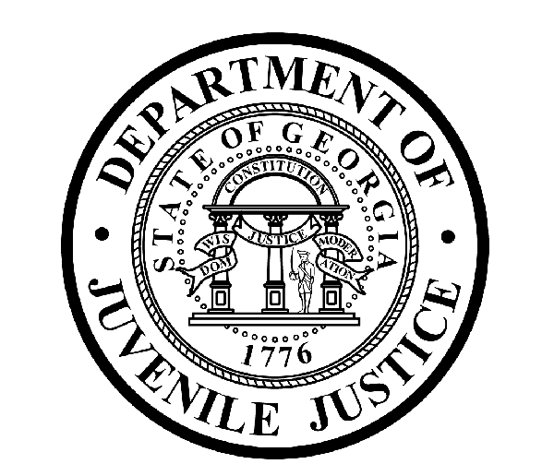

Avery D. Niles, CommissionerDepartment of Juvenile Justice

Jim Shuler, Director3408 Covington Highway ▪ Decatur, Georgia ▪ 30032-1513
Office of CommunicationsTelephone: (404) 508-7147 ▪ Fax: (404) 508-7341
FOR IMMEDIATE RELEASE CONTACT:
Jim Shuler, Director
December 20, 2012 DJJ Communications
(404) 508-7238
JimShuler@djj.state.ga.us

SURPRISE INSPECTIONS CONTINUE AT AUGUSTA YDC
COMMISSIONER’S ADVICE FOR YDC STAFF: ‘DON’T FORGET DJJ TIPLINE’

(AUGUSTA - YDC) Department of Juvenile Justice Commissioner Avery D. Niles made another in a series of surprise inspection visits to the Youth Development Campus (YDC) in Augusta last week,. His continuing mission is to conduct personal check-ups on progress at the campus while the search for a new director is underway. “I will be dropping in for these unannounced assessments to observe operations here first-hand,” Commissioner Niles said.

“My inspection objectives are to talk to staff members, see if they’re getting the support they need from Central Office and to judge for myself if our staff is following the rules 24-7 in order to meet DJJ goals for a safe and secure facility,” said Niles.

In view of recent dismissals, strict personnel actions and criminal prosecutions requested by the Commissioner at the Augusta detention center, Niles reminded YDC Staff that their success at this juvenile corrections facility depends on their strict adherence to policy and requires a steady input of staff reporting and communications to their supervisors.

“We have many dedicated personnel working here,” the Commissioner said. He encouraged cooperation from what he called a “core group of dedicated DJJ Staff at Augusta” to help him bring about professional change and best practices at the Youth Development Campus.

“That’s one reason why I’m also encouraging Augusta YDC Staff to use the DJJ On-line TIP line,” said Commissioner Niles. DJJ Agency Intelligence Analysts devised the innovative tip reporting system earlier this summer to encourage the anonymous flow of critical information from all DJJ employees and detainees. Since then, agency analysts have been referring useful information received in those tips to the DJJ Office of Investigations for assignment and appropriate follow-up actions.

“I want staff from Augusta to know we’re listening in the Commissioner’s Office,” said Niles. “But if I’m not around Augusta and the Corrections staff here has something important to report and they want to keep it anonymous, then all they have to do is send an email,” said Commissioner Niles. Tips submitted online are reviewed solely by the DJJ Intelligence Unit and the sources remain confidential.

Agency Intelligence Analysts say they hope juvenile justice staff members and detainees throughout the state will continue to use the TIP line to report unethical behavior and criminal activity. DJJ Investigators are asking for tips about illegal gang activity, contraband smuggling and staff policy violations in Augusta and anywhere problems need to be fixed within the department. They say a single tip can result in lives saved and injuries prevented.

For persons with information to share about possible dangerous, illegal or unethical activities at Georgia Department of Juvenile Justice facilities, the new TIP Forms can be accessed through the DJJ website at the following links:
http://www.djjnewsandviews.org
http://www.djjnewsandviews.org/gangs101
http://www.djjnewsandviews.org/preageorgia/

Commissioner Niles said the TIP Line is an essential security tool where state employees and the public can submit confidential information. “This online TIP Form is available to all DJJ employees and to the public,” said Commissioner. “If they see something, they can also say something to help safeguard this workplace, while protecting their identity too. But one thing is certain,” said Niles, “It’s very hard to correct our problems if no one is willing to step forward from the inside and let us know what those problems are.”

Commissioner Niles’ core message since he took office in November 2012 has emphasized the critical duty of Juvenile Corrections Officers to enforce safety and security measures at Georgia’s juvenile justice facilities so youth and staff at DJJ can all be safe in a secure learning environment. “I have cautioned DJJ Staff in Augusta and throughout the state that I will continue to seek out safety and security laxes and continue to crack down on violators anywhere they’re found,” Niles said.

(END RELEASE)

