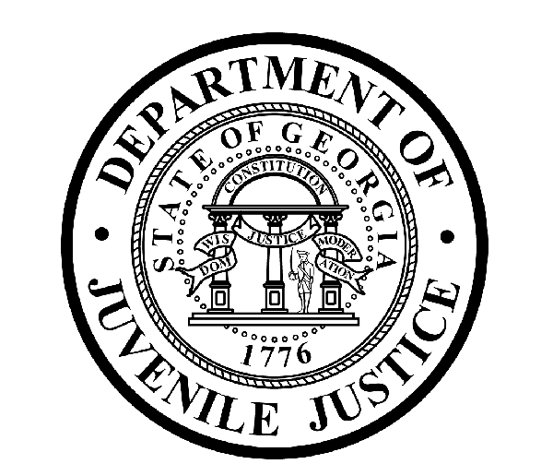

Avery D. Niles, CommissionerDepartment of Juvenile Justice

Jim Shuler, Director3408 Covington Highway ▪ Decatur, Georgia ▪ 30032-1513
Office of CommunicationsTelephone: (404) 508-7147 ▪ Fax: (404) 508-7341
FOR IMMEDIATE RELEASE CONTACT:
Jim Shuler, Director
July 23, 2015 DJJ Communications
(404) 508-7238
JimShuler@djj.state.ga.us

Dept of Juvenile Justice Summer Recruiting in Augusta
DJJ Hiring Correctional Officers at July 23rd Job Fair

(AUGUSTA - GA) More Recruiting fairs are scheduled by the Department of Juvenile Justice this summer in Augusta, Georgia. DJJ Commissioner Avery D. Niles announced the department continues to seek qualified applicants for several corrections officer employment opportunities now available at the Augusta Youth Development Campus (YDC).

Commissioner Niles is sending a team of recruiters to Augusta to interview qualified candidates for Juvenile Corrections Officer (JCO 1 & 2) positions during the upcoming DJJ recruiting fair on Thursday, July 23rd, 2015.

“These scheduled recruiting events are open to the public,” said DJJ Commissioner Niles. On the spot interviews will be conducted for Juvenile Corrections Officer 1 and 2 positions,” the Commissioner said. “..And participation at juvenile corrections career fairs is free.”

The Department of Juvenile Justice has immediate openings for mature applicants and qualified veterans with the professional drive to help juvenile offenders achieve successful reentry into society as productive citizens. “DJJ is a great place for Georgians who want to make their work count,” Commissioner Niles said. The Augusta Recruitment Fair schedule is listed below.

*Please note career fair locations and times may change OR additional career fair dates may be added to our recruiting schedule. Applicants should check the DJJ website for late-breaking schedule changes at www.djjcareers.org BEFORE visiting a DJJ job fair.

Date: Thursday, July 23rd - GENERAL PUBLIC
DJJ Augusta Job Fair - Hiring Juvenile Correction Officer (JCO) 1 & 2 ONLY
Augusta Youth Development Campus (YDC)
3485 Mike Padgett Hwy
Augusta, GA 30906
Time: 10:00 AM - 2:00 PM

( MORE MORE MORE )
(PAGE TWO TWO TWO)

DJJ recruiters are authorized to interview qualified candidates on-site. Applicants should bring their resumes and dress for job interviews. All job seekers can click on www.djjcareers.org for more information about career opportunities in juvenile corrections.

In order to progress smoothly through the interview process for Juvenile Corrections Officers, candidates for the JCO 1 & 2 positions should bring copies of the following:

- Completed State of Georgia application
- State issued ID - Valid Driver License
- Social Security Card
- Birth Certificate
- High School Diploma or GED
- DD214 Long Form with discharge indicated
- Naturalization Forms (if NON-US Citizen)
- If P.O.S.T. Certified, (Please bring two (2) forms of Gov. issued ID & P.O.S.T. Profile)

** If the applicant has a 4-year degree from an accredited college they are exempt from having to take the Compass test or provide proof of acceptable ACT or SAT scores.

Candidates should bring Passing Test Scores as follows:
- Compass Scores (Reading 70 Writing 32)**
- SAT Scores (Verbal: 430 Math: 400) or ACT Scores (Verbal: 18 Math:16)**
- CPE Scores (Reading: 75 Math: 75 English 75)

Former military service members with Honorable Discharge should click on www.djjcareers.org to learn about DJJ's one-time Military Salary Increase Incentive on eligible job titles at “DJJ Careers for Veterans”. There is no charge for participation at juvenile corrections career fairs.

**Please note that career fair times and locations may change and additional career fair dates may be added to our recruiting schedule. Applicants should check the DJJ website for late-breaking schedule changes at http://www.djjnewsandviews.org/djjcareers/ before visiting a job fair.

(END RELEASE)

“DJJ is a great place to make your work count.”
Avery D. Niles, Commissioner

