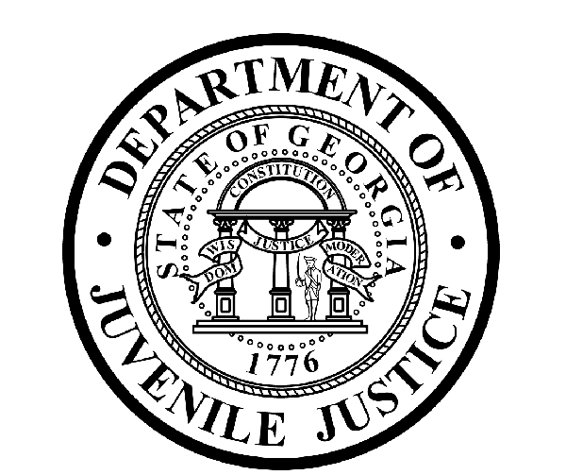

Avery D. Niles, CommissionerDepartment of Juvenile Justice

Jim Shuler, Director3408 Covington Highway ▪ Decatur, Georgia ▪ 30032-1513
Office of CommunicationsTelephone: (404) 508-7147 ▪ Fax: (404) 508-7341
FOR IMMEDIATE RELEASE CONTACT:
Jim Shuler, Director
August 22, 2014 DJJ Communications
(404) 508-7238
JimShuler@djj.state.ga.us

Department of Juvenile Justice Hiring in August
During DJJ “Summer of Opportunity”
Atlanta & Marietta

(STATEWIDE - GA) As the month of August comes to an end, the “Summer of Opportunity” continues at the Human Resources Office for Georgia’s Department of Juvenile Justice. Commissioner Avery D. Niles announced there are two more recruiting fairs at the end of the agency’s August recruitment calendar.

DJJ’s recruiting team will be in the Atlanta Metro Area the last week of August, breaking out boxes of application forms and hoping to connect with job seekers looking for full time careers working with Georgia’s juvenile offenders. “DJJ offers excellent career opportunities to both civilian and veteran applicants who are looking for professional employment in juvenile corrections,” said Commissioner Avery Niles.

“The State of Georgia is an excellent career destination for returning veterans. Our Human Resources Team has been setting up tables at career fairs all over Georgia,” said Commissioner Niles. “However would-be candidates need to know in advance that we’re only seeking mature, responsible adults who are interested in helping these young offenders find their way through very troubled transitions in their lives,” Niles said.

During the end of August, DJJ will be conducting two career fairs in the Atlanta Metro Area on the same day, targeting eligible applicants with both civilian and military backgrounds:

August 28th – MILITARY ONLY
Dobbins Air Force Base - Marietta
1430 First Street, Building #447
Clay National Guard Center, Marietta, GA
10:00AM – 2:00PM
For additional Information check here: http://gdcjobs.com/jsp/index.jsp

(PAGE TWO TWO TWO)
August 28th – GENERAL PUBLIC
Department of Labor Career Center
2943 North Druid Hills, Atlanta, GA
HOURS / 8:00PM – 3:30PM
For additional Information check here: http://www.dol.state.ga.us/Access/Service/ListJobFairEmployers?eventIdentifier=2014-07-30-16.20.03.428745

Participation at juvenile corrections career fairs is free and with the exception of some military recruiting fairs, most events are open to the general public. Serious applicants should dress for success and bring their resumes.

DJJ recruiters will be hiring across Georgia in search of qualified candidates for a wide range of available corrections career opportunities; including Educators and Special Education Teachers, Registered Nurses and Physicians, Corrections and Transportation Officers, Social Workers, Probation and Parole Specialists, Security Emergency Response Teams, I-T Technicians, Food Service Providers and more.

**Please note that career fair times and locations may change and additional career fair dates may be added to our recruiting schedule. Applicants should check the DJJ website for late-breaking schedule changes at http://www.djjnewsandviews.org/djjcareers/ before visiting a job fair.

Job seekers can click on http://www.djjnewsandviews.org/djjcareers/ for more information about professional careers at DJJ. Applicants who have served in the Armed Forces should also click on the section about “DJJ Careers for Veterans” to learn more.

(END RELEASE)

