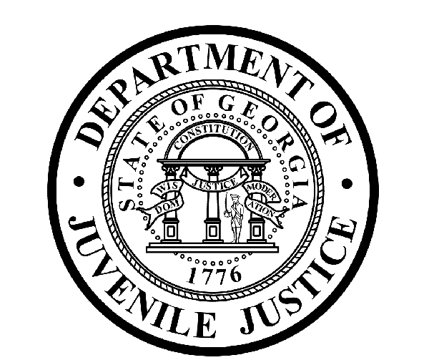

L. Gale Buckner, CommissionerDepartment of Juvenile Justice

Jim Shuler, Director3408 Covington Highway ▪ Decatur, Georgia ▪ 30032-1513
Office of CommunicationsTelephone: (404) 508-7238 ▪ Fax: (404) 508-7341
FOR IMMEDIATE RELEASE CONTACT:
Jim Shuler, Director
August 31, 2012 DJJ Communications
JimShuler@djj.state.ga.us

COMMISSIONER BUCKNER ANNOUNCES RICHARD AMBROSE
APPOINTED NEW DJJ BOARD MEMBER

(ATLANTA - GA) The Commissioner of the Georgia Department of Juvenile Justice is pleased to announce the appointment of a newly named DJJ Board member by Governor Nathan Deal.

Commissioner L. Gale Buckner will confirm the appointment of retired U.S. Army Lieutenant Colonel Richard S. Ambrose during the next regular DJJ Board meeting. “We welcome Mr. Ambrose to the DJJ Board and we are pleased to partner with him as part of this team on our mission to make this a safer and more secure agency for our youth and staff,” said Commissioner Buckner.

Lt. Colonel Ambrose’s distinguished military career spans twenty years with the U.S. Army where he served overseas in Germany and did two tours of duty in Vietnam. He is a graduate of the Army’s Airborne Ranger Schools and after retirement from the armed service, taught ROTC for thirteen years at Dooly County High School. LTC Ambrose was commissioned a second Lieutenant of Infantry when he graduated from the ROTC program at the University of Georgia with a Bachelor’s Degree in Business Administration.

Mr. Ambrose also holds a Master’s Degree in Professional Studies from Western Kentucky University. His extensive military education also includes the basic and advanced infantry officer’s courses and the armed forces staff college.

Board Member Richard Ambrose resides in Vienna in Dooly County, Georgia. He is appointed to the At-Large Board position recently vacated by former Board Member Perry McGuire whose term expired last month. Commissioner Buckner expressed the agency’s appreciation for Board Member McGuire’s service to the Department of Juvenile Justice on the DJJ Board.

The DJJ Board is composed of fifteen members representing each Congressional District in the state. DJJ Board members are appointed by the Governor and provide leadership and guidance to the Commissioner in an advisory capacity to the Department of Juvenile Justice.
(END RELEASE)

