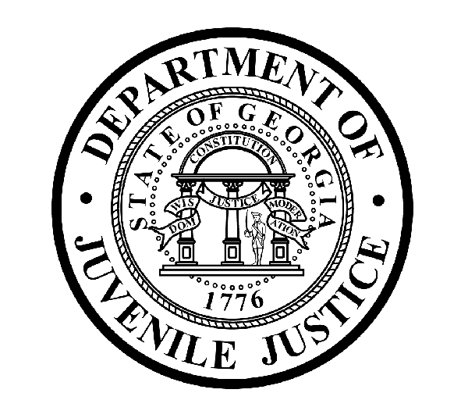

Avery D. Niles, CommissionerDepartment of Juvenile Justice

Jim Shuler, Director3408 Covington Highway ▪ Decatur, Georgia ▪ 30032-1513
Office of CommunicationsTelephone: (404) 508-7147 ▪ Fax: (404) 508-7341
FOR IMMEDIATE RELEASE CONTACT:
Jim Shuler, Director
June 13, 2013 DJJ Communications
(404) 508-7238
JimShuler@djj.state.ga.us

DJJ Advisory Committee Finds Unfinished Sex Abuse Caseload:
Commissioner Suspends Former Chief and 19 Investigators

(ATLANTA - GA) Today Commissioner Avery D. Niles of the Georgia Department of Juvenile Justice announced the immediate suspension with pay of DJJ’s former Chief Investigator and nineteen members of the DJJ Office of Investigations.

The suspensions come less than a week after Commissioner Niles assigned a special DJJ advisory committee to review a federal survey which alleged Georgia has some of the highest rates of sexual abuse incidents in juvenile detention centers in the nation.

The DJJ advisory committee advised the Commissioner this week that more than 20 unfinished internal investigations of sex abuse allegations from 2012 have remained open longer than the 45 days allowed by DJJ policy.

Niles said he ordered immediate suspensions for 19 investigators and their former supervisor.. “pending an investigation into alleged faiure to carry out their assigned duties in a timely manner.”

“This alleged failure of accountability is the last thing we expected to find among an experienced and dedicated staff at DJJ,” said Commissioner Niles. “It is a disturbing breach of confidence and fundamentally unacceptable. These investigators have a duty to protect our youth and employees and to uphold the most basic standards of professional behavior,” said Niles.

Commissioner Niles said today’s suspension were a necessary first step to restore credibility in the Office of Investigations before DJJ can move forward to complete its unfinished investigations and take a closer look at all reported cases and the allegations in the federal survey.

(MORE MORE MORE)

(PAGE TWO)

“We had to take these immediate corrective actions to ensure all reports of sexual abuse and harrassment are thoroughly investigated according to DJJ Policy and sate and federal law,” said Commissioner Niles. “At this time I’m also announcing that the Department of Juvenile Justice will officially request assistance from the Georgia Bureau of Investigation and the Georgia Department of Corrections so we can have independent outside agencies carefully examine and complete these unfinished internal investigations of sex abuse allegations,” the Commissioner said. Niles also reported he recently hired new Chief Investigator Ricky Rich to conduct a comprehensive top-to-bottom reorganization of the Office of Investigations before his advisory committee made this discovery.

“DJJ has pledged to maintain a Zero Tolerance policy for P.R.E.A. violations,” Commissioner Niles said. “P.R.E.A.” is the federal Prison Rape Elimination Act. Georgia’s juvenile justice system is considered a national leader in the PREA program integration process to combat sexual victimization. Niles said his P.R.E.A. Advisory Committee will continue its work to seek evidence of any criminal wrong doing and the Commissioner’s Office will follow-up with vigorous prosecution if evidence warrants.

Since his appointment by the Governor last November, Commissioner Niles has emphasized department transparency and agency-wide get-tough warnings for major policy violations. “At the Department of Juvenile Justice, staff members who violate positions of trust and responsibility will continue to face severe consequences, regardless of time on the job, employee rank or position in this agency. I gave clear warning when I was appointed Commissioner that serious violations of policy will not be tolerated in our professional juvenile justice workplace,” said Niles.

(END RELEASE)

.

