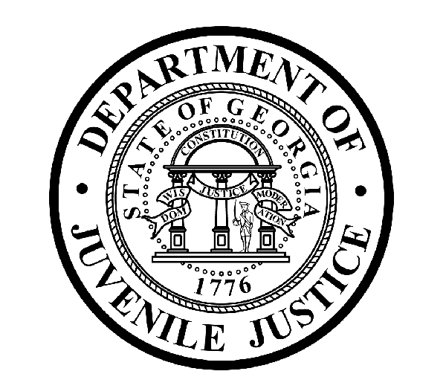

Avery D. Niles, CommissionerDepartment of Juvenile Justice

Jim Shuler, Director3408 Covington Highway ▪ Decatur, Georgia ▪ 30032-1513
Office of CommunicationsTelephone: (404) 508-7147 ▪ Fax: (404) 508-7341
FOR IMMEDIATE RELEASE CONTACT:
Jim Shuler, Director
April 17, 2015 DJJ Communications
(404) 508-7238
JimShuler@djj.state.ga.us

JUVENILE JUSTICE SUPPORTS DEKALB COUNTY ‘PAWS for the CAUSE”
With DJJ’s Rescue-2-Restore Program

(DeKalb County, GA) – Commissioner Avery D. Niles is pleased to announce a team from the DJJ Rescue-2-Restore (R2R) canine adoption program will join with other community partners this weekend to support DeKalb County’s ‘PAWS for the CAUSE’. The annual DeKalb community education event is organized to help reduce crimes against animals by increasing public awareness about animal cruelty and animal neglect.

The Georgia Department of Juvenile Justice will support the event with nationally known animal advocate, Chrissy Kaczynski, who runs the new DJJ Rescue-2-Restore program. The R2R Team will be on hand to walk DJJ’s celebrity ‘therapy-dogs-in-training’ -- “Georgia O’Teef” and “Fred” – and to speak about the innovative new juvenile justice R2R program. Young dog trainers from the Muscogee Youth Development Campus will also attend DJJ’s program booth.

DJJ’s Rescue-2-Restore program works with local rescue organizations to find and save dogs scheduled to be euthanized and enrolls the animals in special training sessions at the Department of Juvenile Justice instead. The daily training is conducted at select DJJ secure facilities by capable young offenders who are chosen to teach skills to the rescued animals to make them better behaved and more adoptable.

The program benefit for DJJ’s young offenders often results in the discovery of feelings of success, empathy and self-worth they can take with them into the outside world and use to become productive citizens upon release. Kaczynski says, “The kids enrolled in the program tell us they look forward to working with rescue animals because the dogs don’t judge them.”

‘PAWS for the CAUSE’ features K-9 demonstrations, an on-site veterinarian to administer low-cost immunizations, and participating rescue agencies will have dogs available for adoption.

DeKalb County’s ‘PAWS for the CAUSE’ is a unique community outreach effort of the DeKalb County District Attorney’s Office, DeKalb County Animal Services & Enforcement, Planned Pethood of Georgia, and the Department of Juvenile Justice Rescue-2-Restore. The event is scheduled in Glenlake Park for Saturday, April 18, at 1121 Church Street in Decatur, from 10:00AM until 2:00PM. Attendance is free to the public.

