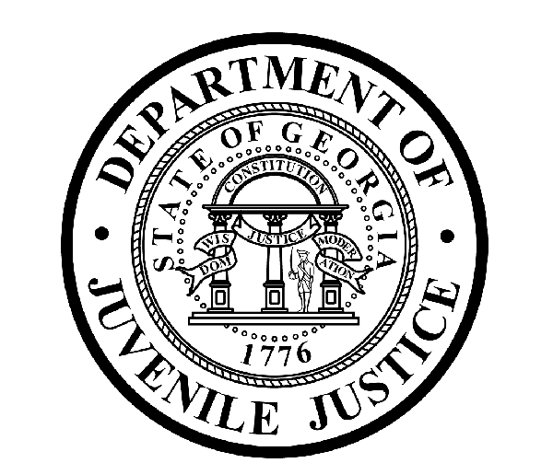

Avery D. Niles, CommissionerDepartment of Juvenile Justice

Jim Shuler, Director3408 Covington Highway ▪ Decatur, Georgia ▪ 30032-1513
Office of CommunicationsTelephone: (404) 508-7147 ▪ Fax: (404) 508-7341
FOR IMMEDIATE RELEASE CONTACT:
Matt Montgomery
April 3, 2014 DJJ Communications
(404) 508-7142
MatthewMontgomery@djj.state.ga.us

DJJ Honors Crime Victims during
National Crime Victims’ Rights Week in April

Atlanta, GA – “30 Years: Restoring the Balance of Justice” is the ‘2014-theme’ for National Crime Victims’ Rights Week across the state and across the country this April 6 through 12. “It’s an important opportunity for all us to pause and remember victims who have suffered as a result of crime,” said Commissioner Avery D. Niles of the Georgia Department of Juvenile Justice.

“Victim advocates from a task force of twelve state agencies we call our ‘Multi-Agency Victim Services Partnership’ are inviting crime victims everywhere to attend Georgia’s annual Victims’ Rights Week ceremony and Open House,” said Commissioner Niles.

The event is scheduled Monday, April 7th at State Offices South, at Tift College in Forsyth. The ceremonies begin at 10:00AM in Roberts Chapel on the Department of Corrections campus, followed by an Open House at noon.

This annual ceremony and event are held to honor crime victims and to increase public awareness about victims’ rights. Then from 12:00 to 4:00PM, the Open House is designed to allow victims and the public to learn more about important services offered by each participating state agency. DJJ Commissioner Niles said crime victims can also meet with Department of Juvenile Justice leadership and staff.

“At DJJ we work 24-seven to maintain secure facilities for Georgia’s juvenile offenders – and to preserve public safety for Georgia citizens,” said the Commissioner. “As we hold Georgia’s most violent youth accountable for their actions, we can never lose sight of the victims of their crimes.”

(MORE, MORE, MORE)

Thousands of Georgia families are affected by crime every year. Crime victims in attendance will have opportunities to meet with leaders from all the sponsoring state agencies at the Open House and to receive information on many victim services:

- Learn about the types of compensation programs available to victims of violent crime
- Receive Victim Services Information
- Make an appointment with Georgia Crime Victims Compensation staff to discuss the status of a claim or determine eligibility for additional benefits
- Learn how to navigate the websites for the Department of Corrections and the State Board of Pardons and Paroles
- Receive current information on offenders, including maximum release date, parole date and where the inmate is incarcerated
- Register to receive further notification of an offender’s status
- Submit Victim Impact Statements

The Department of Juvenile Justice will also have staff available to help educate crime victims about their rights and the juvenile justice process, and to provide information about referrals to community services.

“DJJ is responsible for rehabilitating young offenders,” said Commissioner Niles. “But it’s also our job to protect the victims of juvenile crime so they too can begin to rebuild their own lives. As victim advocates we recognize that about 50-percent of crimes go unreported so only a fraction of victims may get all the help they need. In Georgia, we’ll continue to reach-out and afford victims the fairness, dignity and respect they deserve.”

If you or someone you know is a victim of a crime and would like to attend, contact Latera Davis at the Department of Juvenile Justice Office of Victim Services at 1-866-922-6360 or via email at victimservices@djj.state.ga.us. For more information on Victim Services at DJJ, visit http://www.djjnewsandviews.org/victimservices.

About the Multi-State Agency Victim Services Partnership
The Multi-State Agency Victim Services Partnership is a group of state agencies committed to restoring Georgia crime victims' dignity, safety and well-being by providing leadership, guidance and information to victims and their families through communication, coordination and education. Currently the Multi-State Agency Victim Services Partnership consists of: Administrative Office of the Courts, Georgia Commission on Family Violence, Criminal Justice Coordinating Council, Department of Corrections, Department of Juvenile Justice, Department of Public Safety, Georgia Bureau of Investigation, Governor’s Office of Children and Families, Governor’s Office of Highway Safety, State Board of Pardons and Paroles, and Prosecuting Attorneys’ Council of Georgia.

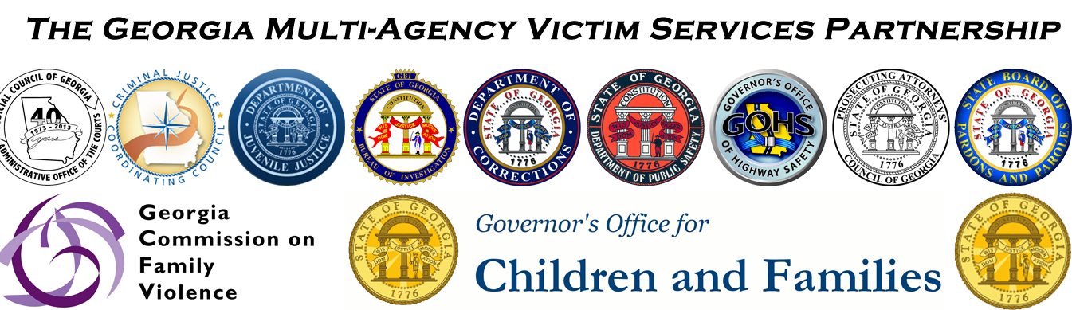

###

(END RELEASE)

