SY 15 - 16 DJJ Wellness
Goal One: National School Lunch Week

Goal 1: National School Lunch Week
Snapshot of Physical Wellness
Facilities recognized the importance of physical health by having kickball games with youth and staff, Iron Man Competitions, yoga and Zumba classes, wellness boot camps, a field day with relay events, and focus on healthy eating. The youth were able to stretch their legs and break a sweat!

Snapshot of Mental Wellness
Mental health activities were aimed at enhancing mental and emotional wellbeing. Youth participated in cognitive games with staff and peers, coming up with emotions for each letter of the alphabet and having discussion, practicing exercises for better sleep, and sharing stories with one another.

Snapshot of Economic Wellness
Staff took to providing educational activities and presentations to assist youth in their economic and financial understanding. Several facilities hosted presentations on banking basics, how to complete a check, and balancing a checkbook. Muscogee YDC taught youth about the importance of their finances by incorporating financial comic books featuring super heroes. Aaron Cohn RYDC created a large check to show exhibit what a check looks like and what each line and number means. Youth at Eastman RYDC shared financial stories and participated in playing Monopoly Empire. Sumter YDC tasked the youth with “shopping for groceries” on a budget while using coupons.
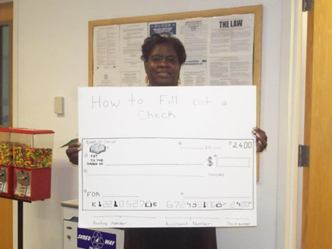
Aaron Cohn RYDC

Snapshot of Spiritual Wellness
Youth practiced enhancing their spiritual wellbeing by participating in yoga classes, coloring to the sound of inspirational music, and participating in volunteer led meditation sessions.
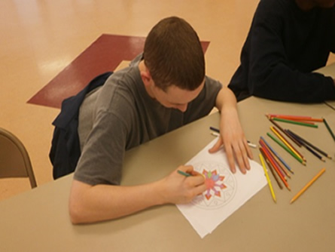
Coloring and listening to inspirational music at the Sumter YDC
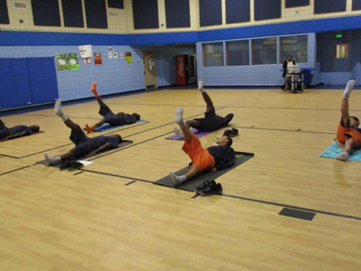
DeKalb RYDC Yoga
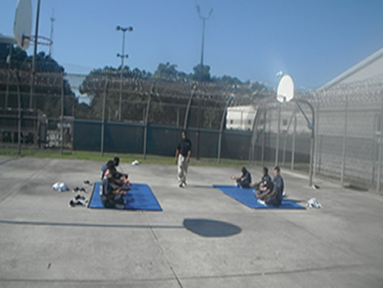
Savannah RYDC Yoga
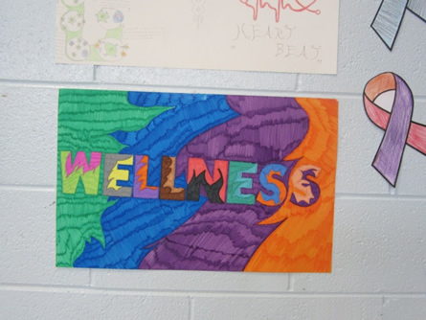
Art Contest at the Sandersville RYDC

Snapshot of Social Wellness
The youth enjoyed social time and activities in a variety of ways! A Taboo party, Phase 10 games, and a PBIS movie night are a few of the ways the youth enhanced their social wellbeing. Atlanta YDC allowed youth to socialize with the Fulton County Fire Department by having a Fire & Safety Rescue interactive presentation with the local firefighters.
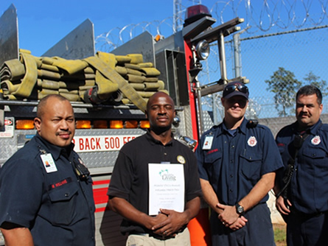
Overall, the youth were able to gain a great understanding of overall wellbeing by taking a look at snapshots of five areas of wellness. Youth and staff were able to enjoy each other’s’ company while learning valuable lessons about health – in all aspects.
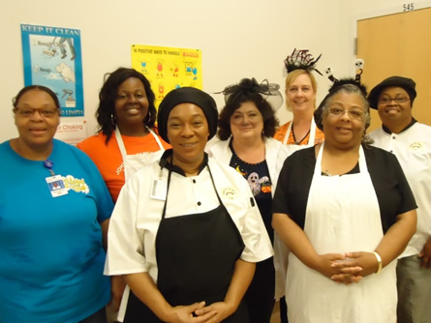
Guest Servers and Food Services Staff at the Muscogee YDC

