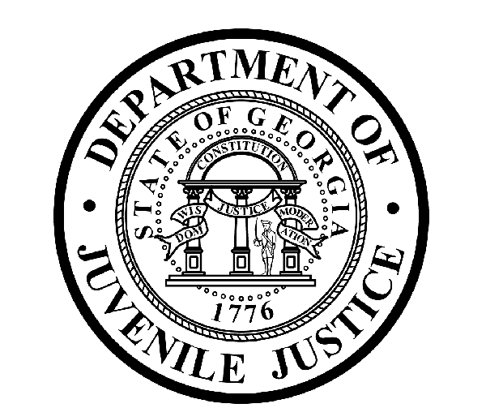

Avery D. Niles, CommissionerDepartment of Juvenile Justice

Scott Mall3408 Covington Highway ▪ Decatur, Georgia ▪ 30032-1513
Office of CommunicationsTelephone: (404) 508-7147 ▪ Fax: (404) 508-7341
FOR IMMEDIATE RELEASE CONTACT:
Jim Shuler
August 30, 2017 DJJ Communications
(404) 508-7147
JimShuler@djj.state.ga.us

DJJ Citizens’ Academy Comes to Milledgeville
- A Look Inside Georgia Juvenile Justice Reform Innovations -

(Milledgeville - GA) Department of Juvenile Justice (DJJ) Commissioner Avery D. Niles is pleased to announce the latest public session of DJJ Citizens' Academy scheduled to convene in Milledgeville in mid-October. The Citizens’ Academy is an intensive five-week workshop planned by the Commissioner to provide the public with an in-depth look into the on-site operations and innovative reforms at work in the Georgia juvenile justice system.

This Citizens’ Academy curriculum was developed at DJJ to help educate concerned citizens, local leaders and community stakeholders about meaningful restructurings in state juvenile justice. Commissioner Niles said Governor Nathan Deal’s support has helped enhance life-changing system-wide changes to reduce the number of young offenders and recidivism rates in Georgia’s juvenile justice populations.

DJJ will roll out the Milledgeville Citizens' Academy on Tuesday, October 17th. Academy sessions will be scheduled at DJJ secure facilities, DJJ Community Service Offices and local courts in Baldwin County and the City of Milledgeville. The Citizens’ Academy provides transparency in state government by allowing citizens to observe Georgia’s juvenile justice reforms at work.

“Our Milledgeville Citizens' Academy will provide a select panel of participants with a 360-degree view of the scope of reforms in juvenile correctional practices,” Commissioner Niles said. The course will commence with an agency overview and introduction to DJJ executive leadership. The curriculum covers topics from secure facilities and community supervision, to GEDs, high school diplomas and vocational education opportunities available through DJJ’s Georgia Preparatory Academy.

“We support the governor's vision for a safer and better-educated Georgia by sustaining a secure environment where our youth can experience better learning opportunities and by ensuring the quality of that education through outstanding teachers and administrators and by continuing to maintain professional accreditation in Georgia’s 181st school district at DJJ,” Niles said.

(more)

(Page 2)

“Members of the Milledgeville Citizens’ Academy will have a first-hand opportunity to observe DJJ's
commitment to our young offenders and their families,” the Commissioner said. “They’ll learn how our juvenile reentry programs make productive lives possible again as our youth return to their neighborhoods. And they’ll learn about DJJ’s non-negotiable mission to promote safer communities for all Georgians by holding our juvenile offenders accountable.”

DJJ Citizens' Academy invitations are limited by the Commissioner’s Office to a roster of 20 Milledgeville-area residents. An application process will determine consideration for admission. Criminal history and background clearance results must be approved by the Commissioner’s Office prior to participation. A schedule for future sessions of the DJJ Citizens’ Academies is under development.

Additional Academy schedules will be announced on DJJ’s News & Views website at
http://www.djjnewsandviews.org/. For additional information, please contact:

Latera Davis, Director
Office of Victim and Volunteer Services
Division of Planning and Preparedness
Georgia Department of Juvenile Justice
Office: 404-508-6532
Cell: 404-683-8819
lateradavis@djj.state.ga.us

(END RELEASE)

###

ABOUT DJJ
The Georgia Department of Juvenile Justice (DJJ) is a multi-faceted agency that serves the needs of this state`s young offenders up to the age of 21. The Department employs more than 4,000 men and women at 26 secure facilities and 97 community services offices throughout the state to effect justice and redirect the young lives in the agency`s care.

Including those who are placed on probation, thousands of youths are diverted each year to evidence-based community programs, sentenced to short-term incarceration or committed to the Department`s long-term custody by the Juvenile Courts. It is the duty of DJJ’s professional corrections staff to preserve public safety and safeguard the citizens of Georgia, as well as protect the victims of crimes so that they can rebuild their lives.

At the same time, DJJ holds juvenile offenders accountable for their delinquent conduct so that they can take responsibility for their actions through probation, supervision and secure detention. The youth are provided with medical and psychological treatment, as well as specialized education and programs designed to equip them with the social, intellectual and emotional tools needed to achieve their successful reentry and reintegration into community, workplace and neighborhood settings as more productive and law-abiding citizens.

