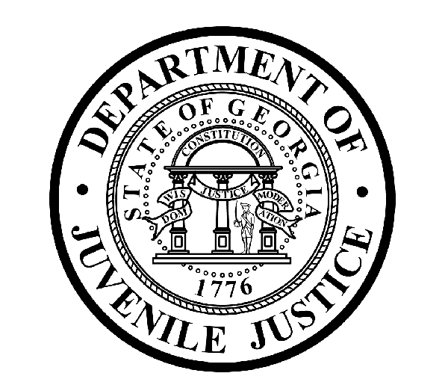

Avery D. Niles, CommissionerDepartment of Juvenile Justice

Scott Mall3408 Covington Highway ▪ Decatur, Georgia ▪ 30032-1513
Office of CommunicationsTelephone: (404) 508-7147 ▪ Fax: (404) 508-7341
FOR IMMEDIATE RELEASE CONTACT:
Jim Shuler
October 6, 2017 DJJ Communications
(404) 508-7147
JimShuler@djj.state.ga.us

Come Work for Justice in Your Community!
Juvenile Justice Recruiting Correctional Officers
DJJ Now Hiring in Atlanta & Washington, GA

(STATEWIDE- GA) If you’re ready to work for justice in your community, the Department of Juvenile Justice (DJJ) is recruiting responsible adults like you who care about at-risk kids from around Georgia. DJJ will help qualified candidates find the career positions they’ve been looking for in one of Georgia’s most fulfilling criminal justice career areas.

During the month of October, DJJ recruiters will hold on-site interviews in Metro Atlanta and Washington, Georgia for Juvenile Correctional Officer (JCO) positions. Interviews for these positions are being held at the Clayton County Department of Labor and the Pope Center in Washington, Georgia.

Commissioner Avery D. Niles said it takes an insightful, disciplined and caring individual to be the kind of JCO who can make a positive difference in the lives of Georgia’s incarcerated youth.

Niles stated, “If you have correctional experience, DJJ wants you. And if you’re a candidate who needs corrections training, DJJ will teach you.”

*Please note career event locations and times may change OR additional career event dates may be added to the DJJ recruiting schedule. Applicants should check the DJJ website for late-breaking schedule changes at www.djjcareers.org BEFORE visiting a DJJ hiring event.

Date: Thursday, October 12 – OPEN to GENERAL PUBLIC
On-site interviews for Juvenile Correctional Officer (JCO) positions
for employment at Atlanta Youth Development Campus (YDC) in College Park
Clayton County Department of Labor
Location: 1630 Phoenix Blvd., #200
Atlanta, GA 30349
Time: 9:00 a.m. – 1:00 p.m.

(more)
(page two)

Date: Thursday, October 26 – OPEN to GENERAL PUBLIC
On-site interviews for Juvenile Correctional Officer (JCO) positions
for employment at Wilkes Regional Youth Detention Center (RYDC) in Washington, GA
The Pope Center
Location: 48-B Lexington Avenue
Washington, GA 30673
Time: 10:00 a.m. – 2:00 p.m.

DJJ runs its own certified state academy where a rigorous training program is provided for recruits. The agency offers competitive annual salaries starting at $27,936.00 with a salary increase at six months, followed by another salary increase with promotion at year-one. DJJ also offers comprehensive employee health and benefit packages for JCO positions plus incentives for military service. DJJ supports the professional growth of its new JCOs by offering career development training and opportunities.

“We rely upon the DJJ team’s individual problem-solving abilities and unique life experiences to change young lives for the better,” explained Commissioner Niles. “That’s why we recruit a workforce for service in our secure youth development campuses and our communities that’s diverse, inclusive and motivated to help guide our young offenders toward significant change in their lives.”

*Clearing a background check is mandatory. Business professional dress for onsite interviews is required; current law enforcement or military personnel may come in uniform.

WHAT TO BRING:
To ensure eligibility for consideration of employment, applicants for Juvenile Correctional Officer positions MUST bring copies of these important documents to the interview process:

- Completed Georgia State Merit Application
- Valid Driver’s License
- Social Security Card
- Certified Birth Certificate
- High School Diploma or GED
- DD214 Long Form with discharge indicated
- If P.O.S.T. Certified, please bring two (2) forms of Government issued ID & P.O.S.T. Profile **
- Naturalization Forms if Non-US Citizen
- Compass Scores (Reading: 70 Writing: 32)** Accuplacer (Reading: 55 Writing: 60 Numerical: 34) **
- SAT Scores (Verbal: 430 Math: 400) or ACT Scores (Verbal: 18 Math: 16)**

**Applicants with a 4-year degree from an accredited college are exempt from taking the Compass test or providing proof of acceptable ACT or SAT scores.

“While we welcome potential employees from all walks of life, we’re always looking for high-performance applicants who can adapt their past experience from military, law enforcement or adult correctional backgrounds to apply in a structured juvenile justice environment,” the Commissioner said. “Our team members accept the personal challenge to help these young people embrace better decision-making abilities designed to alter their offending behaviors and prepare them to go home where they can build successful futures in their communities.”

DJJ is searching for these special candidates to become part of our dedicated group of juvenile justice professionals. Interested job seekers can click on www.djjcareers.org for more information about career opportunities in juvenile corrections. DJJ is ‘Veteran-Friendly.’ Former military service members with Honorable Discharges should also click on www.djjcareers.org to learn about DJJ's one-time Military Salary Increase Incentive on eligible job titles at “DJJ Careers for Veterans.”

(more)

(page 3)

“DJJ is a great place to make your work count.”
Avery D. Niles, Commissioner
Georgia Department of Juvenile Justice

###

ABOUT DJJ
The Georgia Department of Juvenile Justice (DJJ) is a multi-faceted agency that serves the needs of this state`s young offenders up to the age of 21. The Department employs more than 4,000 men and women at 26 secure facilities and 97 community services offices throughout the state to effect justice and redirect the young lives in the agency`s care.

Including those who are placed on probation, thousands of youths are diverted each year to evidence-based community programs, sentenced to short-term incarceration or committed to the Department`s long-term custody by the Juvenile Courts. It is the duty of DJJ’s professional corrections staff to preserve public safety and safeguard the citizens of Georgia, as well as protect the victims of crimes so that they can rebuild their lives.

At the same time, DJJ holds juvenile offenders accountable for their delinquent conduct so that they can take responsibility for their actions through probation, supervision and secure detention. The youth are provided with medical and psychological treatment, as well as specialized education and programs designed to equip them with the social, intellectual and emotional tools needed to achieve their successful reentry and reintegration into community, workplace and neighborhood settings as more productive and law-abiding citizens.

