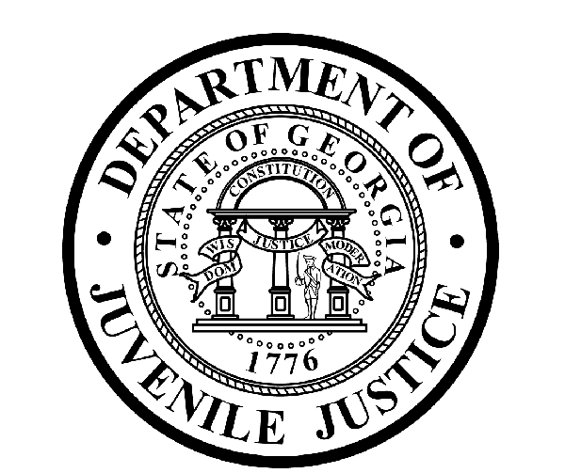

Avery D. Niles, CommissionerDepartment of Juvenile Justice

Scott Mall3408 Covington Highway ▪ Decatur, Georgia ▪ 30032-1513
Office of CommunicationsTelephone: (404) 508-7147 ▪ Fax: (404) 508-7341
FOR IMMEDIATE RELEASE CONTACT:
Jim Shuler
August 2, 2017 DJJ Communications
(404) 508-7147
JimShuler@djj.state.ga.us

Come Work for Justice in Your Community!
Department of Juvenile Justice Wants New Recruits
For Careers in Corrections
Atlanta, Decatur, Milledgeville & Washington

(STATEWIDE-GA) Are you ready to work for justice in your community? The Department of Juvenile Justice (DJJ) is recruiting responsible adults like you who care about at-risk kids from around Georgia. Commissioner Avery D. Niles stated, “If you have corrections experience, DJJ wants you. And if you’re a candidate who needs corrections training, DJJ will teach you.”

Commissioner Niles said it takes a well-trained and well-disciplined individual to be the kind of Juvenile Correctional Officer (JCO) who can make a positive difference in the lives of incarcerated youth. DJJ will help qualified candidates find the career – positive positions they’ve been looking for here, in one of Georgia’s most rewarding criminal justice career areas.

“At our youth development centers and campuses and in our communities, we help young offenders change their lives for the better, so we recruit a diverse and inclusive workforce,” explained Niles. “We rely upon the unique life experiences and individual problem-solving abilities of our team of capable professionals to change young lives at DJJ every day.”

The Commissioner has authorized agency recruiters to offer competitive starting salaries, military incentives, and comprehensive employee health and benefit packages for JCO positions. DJJ runs its own certified state academy where a rigorous training program is provided for recruits. The agency pays a salary increase at six months and a salary increase with promotion at one year. DJJ also supports the professional growth of new JCOs by offering career development training and opportunities.

“We’re always looking for high-performance applicants who can adapt their past experience from military, law enforcement or adult correctional backgrounds to apply in a structured juvenile justice environment,” the Commissioner said. “Our team members accept a personal challenge to help these young people embrace better decision-making to change their offending behaviors and prepare them to go home and build successful futures in their communities.”
(page two)

*Clearing a background check is mandatory. Professional dress for onsite interviews is required; current law enforcement or military personnel may come in uniform.

*Please note career fair locations and times may change OR additional career fair dates may be added to the DJJ recruiting schedule. Applicants should check the DJJ website for late-breaking schedule changes at www.djjcareers.org BEFORE visiting a DJJ job fair.

Date: Tuesday, August 8 – OPEN to GENERAL PUBLIC
On-site interviews for Juvenile Correctional Officer (JCO)
for employment at Milledgeville Youth Development Campus (YDC)
Georgia Department of Labor, Career Center
Location: 156 Roberson Mill Road
Milledgeville, GA 31061
Time: 9:00 a.m. – 12:00 p.m.
Contact: 478-445-3131

Date: Tuesday, August 15 – OPEN to GENERAL PUBLIC
On-site interviews for Juvenile Correctional Officer (JCO)
for employment at Atlanta Metro Regional Youth Detention Center (RYDC)
Location: Clayton County Department of Labor
1630 Phoenix Blvd. #200
Atlanta, GA 30349
Time: 10:00 a.m. – 2:00 p.m.
Contact: 404-635-4422

Date: Wednesday, August 16 – OPEN to GENERAL PUBLIC
On-site interviews for Juvenile Correctional Officer (JCO)/Housekeeper/Food Service Worker
positions for employment at Wilkes Regional Youth Detention Center (RYDC)
The Pope Center
Location: 48-B Lexington Ave.
Washington, GA 30673
Time: 10:00 a.m. – 2:00 p.m.
Contact: 404-807-2611

Date: Thursday, August 24 – OPEN to GENERAL PUBLIC
DJJ Job Fair
Location: Beulah Baptist Church
Family Life Center
2340 Clifton Springs Rd.
Decatur, GA 30034
Time: 10:00 a.m. - 2:00 p.m.
Contact: 404-508-6500

Date: Wednesday, August 30 – OPEN to GENERAL PUBLIC
DJJ Job Fair
On-site interviews for Juvenile Correctional Officer (JCO)
for employment at Wilkes Regional Youth Detention Center (RYDC)
The Pope Center
48-B Lexington Ave.
Washington, GA 30673
Time: 10:00 a.m. - 2:00 p.m.
Contact: 404-807-2611

(more)
(page three)
WHAT TO BRING:
To ensure eligibility for consideration of employment, applicants for Juvenile Correctional Officer positions must bring copies of these important documents to the interview process:

- Compass Scores (Reading: 70 Writing: 32)** Accuplacer (Reading: 55 Writing: 60 Numerical: 34) **
- SAT Scores (Verbal: 430 Math: 400) or ACT Scores (Verbal: 18 Math: 16)**
- Valid Driver’s License
- Social Security Card
- Birth Certificate
- High School Diploma or GED
- DD214 Long Form with discharge indicated
- Naturalization Forms if Non-US Citizen
- If P.O.S.T. Certified, please bring two (2) forms of Government issued ID & P.O.S.T. Profile **

**Applicants with a 4-year degree from an accredited college are exempt from taking the Compass test or providing proof of acceptable ACT or SAT scores.

DJJ is searching for special candidates to become part of our dedicated team of professionals. Interested job seekers can click on www.djjcareers.org for more information about career opportunities in juvenile corrections. DJJ is ‘Veteran-Friendly.’ Former military service members with Honorable Discharges should also click on www.djjcareers.org to learn about DJJ's one-time Military Salary Increase Incentive on eligible job titles at “DJJ Careers for Veterans.”

“DJJ is a great place to make your work count.”
Avery D. Niles, Commissioner
Georgia Department of Juvenile Justice

###

ABOUT DJJ
The Georgia Department of Juvenile Justice (DJJ) is a multi-faceted agency that serves the needs of this state`s young offenders up to the age of 21. The Department employs more than 4,000 men and women at 26 secure facilities and 97 community services offices throughout the state to effect justice and redirect the young lives in the agency`s care.

Including those who are placed on probation, thousands of youths are diverted each year to evidence-based community programs, sentenced to short-term incarceration or committed to the Department`s long-term custody by the Juvenile Courts. It is the duty of DJJ’s professional corrections staff to preserve public safety and safeguard the citizens of Georgia, as well as protect the victims of crimes so that they can rebuild their lives.

At the same time, DJJ holds juvenile offenders accountable for their delinquent conduct so that they can take responsibility for their actions through probation, supervision and secure detention. The youth are provided with medical and psychological treatment, as well as specialized education and programs designed to equip them with the social, intellectual and emotional tools needed to achieve their successful reentry and reintegration into community, workplace and neighborhood settings as more productive and law-abiding citizens.

