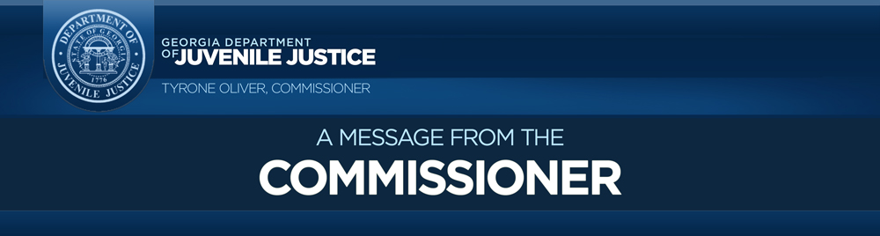
All staff,
As the Coronavirus (COVID-19) impact in Georgia continues, DJJ remains focused on the health and safety of our employees and youth. That is why today, we activated a general information “Helpline” to address questions from staff and the general public regarding DJJ’s response to the virus. The “Helpline” at 404-508-1398 will be monitored by DJJ’s Office of Emergency Management (OEM) professionals and available Monday through Friday from 8 a.m. until 5 p.m. The OEM operators will make every effort to answer each caller’s question, but some topics may require routing to other Divisions. The “Helpline” will remain active until further notice, but employees should always consult with their chain of command on any concern.
Additionally, since the first reported case of the virus in Georgia, our leadership team has instituted several procedures in our secure and nonsecure facilities to help minimize the spread of the illness, which includes:
Facilities/Medical
- Suspension of all visitation at our secure facilities and DJJ offices except for Judiciary or emergency-related matters.
- Elimination of all nonessential movement of youth outside the facility
- Increased communication time for youth with parents or guardian through video conferencing
- Screening of youth before they enter the facility with temperature checks and COVID-19 screening questions
- Screening of all visitors providing direct care services to youth before entry
- Continuation of Behavior health and counseling services to the youth
Education
- Closing of the DJJ school system - (inside secure facilities)
- Educational Transitional Centers (community schools)
- Continuation of alternative Educational Services to the youth
Employees
- Expanded the number of employees who remote work or telework
- Encouraged all employees when possible to practice social distancing
- Notified staff to self-screen for signs of infection such as cough, fever, and shortness of breath
- Providing one free meal a day to secure facility staff through our food service department
- Instructed both staff and youth on proper handwashing techniques and how to identify symptoms of the virus
New Video Message
- Commissioner Tyrone Oliver and Dr. Michelle Staples-Horne
For the most accurate and update to date status on Georgia’s COVID-19 response, visit the Georgia Department of Public Health. Also, in the “Employee” section on the DJJ website, we are compiling useful documents and links to keep you informed.
Currently, we have no case of the virus in any of our secure or nonsecure facilities. As always, we will continue to monitor the situation during this challenging time and remember your wellbeing remains our top priority. Thank you all for all the extraordinary efforts.

Respectfully,
Tyrone Oliver, Commissioner

Please note that the “Helpline” should not be utilized for professional medical advice. The State of Georgia has a new COVID-19 hotline. If you believe that you are experiencing symptoms of COVID-19 or have been exposed to the novel coronavirus, please contact your primary care doctor, an urgent care clinic, or your local federally qualified healthcare center. Please do not show up unannounced at an emergency room or health care facility. State of Georgia COVID-19 Hotline: (844) 442-2681

