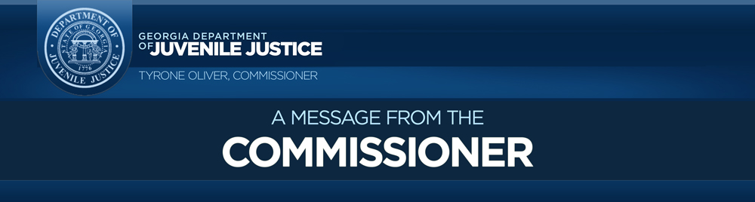
March 25, 2020
DJJ Staff,
Yesterday evening, I was informed that an employee at the Metro Regional Youth Detention Center (RYDC) has tested positive for the Coronavirus (COVID-19). Prior to receiving confirmation of this case, we had already taken steps to control the spread of COVID-19, and we immediately took additional steps to determine the exposure level to staff and youth.
The employee last reported to work on Monday, March 16, and is currently under the care of medical professionals in a local area hospital. Due to the HIPAA privacy act, I am unable to divulge the staffer's identity but ask that you keep the team member in your thoughts and prayers.
We discovered through our investigation, the employee worked in a limited capacity in the facility and had no contact with our youth and minimal contact with staff. The area where the infected employee worked has been cleaned and disinfected.
We are in the process of identifying any coworkers that may have been exposed. We monitor daily all youth and employees that are exhibiting signs and symptoms of COVID-19 and provide appropriate guidance for exclusion and/or isolation.
Due to our diligent and pro-active cleaning and handwashing practices since early March, it appears no spread has occurred to other staff from this individual case.
In the wake of the COVID-19 intrusion, we are continuing to follow the CDC and DPH guidelines and best practices to further prevent the spread of the virus while protecting the youth and staff within DJJ.

WHAT WE ARE CONTINUING TO DO
Since early March, DJJ has incorporated rigorous measures to safeguard against possible transmission of the COVID-19 infection in our facilities and offices. These measures include:
- Allowing staff to telework whenever possible in order to promote social distancing
- Suspension of visitation between youth and family members
- Suspension of all volunteers entering the facilities
- Screening checks of all correctional officers, visitors, and other staff entering the facilities
- An aggressive and extensive cleaning schedule that disinfects all areas within the facilities
- Soap and handwashing availability as well as hand sanitizer made available to all staff
- Screening for all admitted youth
- Continuation of monitoring the health status of the youth while admitted

MONITORING YOUR HEALTH
Due to the multiple signs and symptoms of COVID-19, assume anyone can be infected and practice these prevention measures.
- Complete a self-examination each day before reporting to work.
- Stay home if you are ill and notify your supervisor.
- Avoid close contact with people who are sick; this includes family members.
- Practice social distancing of six feet whenever possible.
- Cough or sneeze into your sleeve or elbow. Wear a mask if you have these symptoms.
- Avoid touching your eyes, nose, and mouth with unwashed hands.
- Wash your hands often with soap and water for at least 20 seconds.
- Use an alcohol-based hand sanitizer that contains at least 60 percent alcohol if soap and water are not available.
- If youth exhibit symptoms within the facility that require isolation, you should wear Personal Protective Equipment (PPE) only if you are in direct contact with the youth.
I ask that you please remember to remain calm during this time of crisis. We are working diligently during this pandemic to protect you and your family against COVID-19. If you need additional information regarding the virus, please utilize a reputable website site such as the CDC or Georgia DPH. If you need further support for your emotional health, please do not hesitate to contact our employee assistant program at 1-833-276-0988.
Thank you for all you do for the State of Georgia, this agency and the youth in our care. God Bless.

Respectfully,
Tyrone Oliver, Commissioner

The State of Georgia has a new COVID-19 hotline. If you believe that you are experiencing symptoms of COVID-19 or have been exposed to the novel coronavirus, please contact your primary care doctor, an urgent care clinic, or your local federally qualified healthcare center. Please do not show up unannounced at an emergency room or health care facility. State of Georgia COVID-19 Hotline: (844) 442-2681

