|  |  |
| --- | --- |
| Adobe Sign - CCS Media  DJJ New Hire Packet Documentation | The Georgia Department of Juvenile Justice is excited to present our New Hire Packet online process powered by Adobe Sign.  DJJ HR Department |

Contents

**User Setup and Administration** 2

**Send New Hire Packet to Applicant** 6

**Managing your New Hire Packets** 13

**Document Downloads** 17

# **User Setup and Administration**

To have a new user set up to use Adobe Sign, please open an internal DJJ Work Order. When the work order is processed, you will receive the below notification from the Adobe Sign system to set up and activate your account. Click on the “Activate Okta Account” button in the email and complete the setup steps.

|  |
| --- |
|  |
| |  | | --- | | **GEORGIA DEPARTMENT OF JUVENILE JUSTICE - Welcome to Adobe Acrobat Sign Solutions for Government** | | Hello **XXXX**, | | Please do not forward this email. | | You received this email because you have been identified by your organization as the administrator for its Adobe Acrobat Sign Solutions for Government FedRAMP Moderate account. This email was sent from Okta because Adobe has partnered with Okta to use its FedRAMP Moderate Authorized Identity as a Service platform. You can feel confident regarding the combination of Adobe and Okta services as Adobe also uses Okta internally. | | You will need to take these actions to allow your organization to use Adobe Acrobat Sign Solutions for Government: | | **Step 1: Initiating the Administrator Account** Set up your Administrator identity in the Okta system using the following link (*click only once*): [Activate Okta Account](https://urldefense.com/v3/__https:/adobesign-a19355b1-06bf-41b2-b587-ef0157f2630d.okta.com/tokens/UzB3rEo7ktfFxFZB6o1O/verify__;!!HWVSVPY!lAWvSd7NNn1GVE_m8aQjLhs3HPVKMmB1IFCAt24vzQzgIMXnOk42nd1ThSPlTyEaFPW2UeAUIpCe4QWrO7qEhEk$) Access using this email expires in **7 days**  Your username is [**XXXXX**@djj.state.ga.us](mailto:XXXXX@djj.state.ga.us).  Your organization's sign-in page is:  [**https://adobesign-a19355b1-06bf-41b2-b587-ef0157f2630d.okta.com**](https://urldefense.com/v3/__https:/adobesign-a19355b1-06bf-41b2-b587-ef0157f2630d.okta.com__;!!HWVSVPY!lAWvSd7NNn1GVE_m8aQjLhs3HPVKMmB1IFCAt24vzQzgIMXnOk42nd1ThSPlTyEaFPW2UeAUIpCe4QWrzDu-NMA$)  **NOTE:** Bookmark the above link to access the Adobe Sign system easily going forward. | | Thank you for choosing Adobe Acrobat Sign for Government | |
| This is an automatically generated message from [Okta](https://urldefense.com/v3/__https:/www.okta.com__;!!HWVSVPY!lAWvSd7NNn1GVE_m8aQjLhs3HPVKMmB1IFCAt24vzQzgIMXnOk42nd1ThSPlTyEaFPW2UeAUIpCe4QWrUI4e1II$) . Replies are not monitored or answered. |

TIP

Once you complete the Okta setup process, you will be sent another email from the system to activate your account. Click on the “activate your account” link to complete the new account setup.



**From:** Adobe Sign <adobesign@adobesign.us>   
**Sent:** Friday, September 29, 2023 9:42 AM  
**To:** Moody, Adam <Adam.Moody@djj.state.ga.us>  
**Subject:** Welcome to Adobe Acrobat Sign - please confirm your email address

**CAUTION:** This email originated from outside of the organization. Do not click links or open attachments unless you recognize the sender and know the content is safe.



|  |
| --- |
| We require you to confirm your email address before sending any agreements from Adobe Acrobat Sign.  Please click the following link to [activate your account](https://urldefense.com/v3/__https:/gdojj.na1.adobesign.us/public/v?eid=CBJCHBCAABAAyrIXo9PqWYa1TbEe9fBoURHRgf2sIqw0&evt=CBNCKBAAHBCAABAA9iscuFxlM3lnIWyi0cgTIqxpw0TtGOIB__;!!HWVSVPY!n1CYcgt0m5LGosj3TwULKjfYdbjkkKsb3rYRJ56DEfSG2wyLqPHwvPvwEssFvNoYBHzb586pKKzG6NzB8AVorryV5BIRWS8$).  If the above link does not work you can paste the following address into your browser:  [https://gdojj.na1.adobesign.us/public/v?eid=CBJCHBCAABAAyrIXo9PqWYa1TbEe9fBoURHRgf2sIqw0&evt=CBNCKBAAHBCAABAA9iscuFxlM3lnIWyi0cgTIqxpw0TtGOIB](https://urldefense.com/v3/__https:/gdojj.na1.adobesign.us/public/v?eid=CBJCHBCAABAAyrIXo9PqWYa1TbEe9fBoURHRgf2sIqw0&evt=CBNCKBAAHBCAABAA9iscuFxlM3lnIWyi0cgTIqxpw0TtGOIB__;!!HWVSVPY!n1CYcgt0m5LGosj3TwULKjfYdbjkkKsb3rYRJ56DEfSG2wyLqPHwvPvwEssFvNoYBHzb586pKKzG6NzB8AVorryV5BIRWS8$) |

|  |
| --- |
| my sig   Company Logo  To ensure that you continue receiving our emails, please add [adobesign@adobesign.us](mailto:adobesign@adobesign.us) to your address book or safe list. |

Once you are successfully logged into the system you will see the below screen. Click on the “Adobe Acrobat Sign” application.

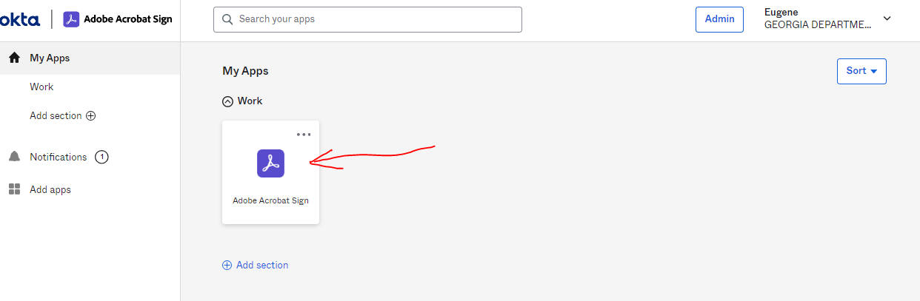

You will then be prompted with the below login screen. Enter your email address into the Email: box and then click on the **TAB** key on your keyboard to launch your session. You should not enter a password.

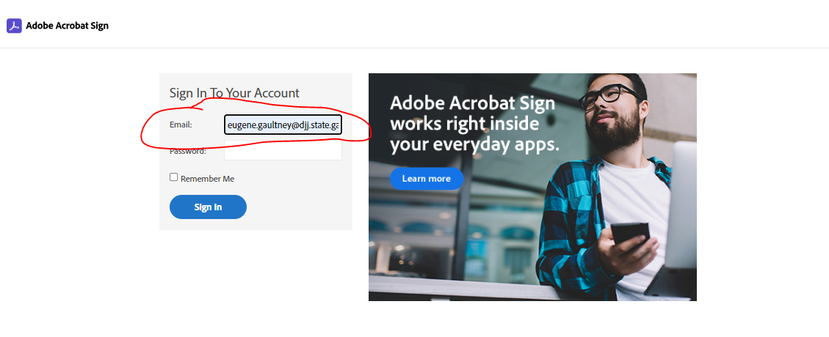

# **Send New Hire Packet to Applicant**

When you are successfully logged into the Adobe Sign system, the below “Home” screen will display.

You should see the three highlighted tabs at the top of the screen:

1. Home
2. Send
3. Manage

When you select the “Send” tab, you will see the below screen.

You will enter the applicants email in the first Recipient box and then enter your email as the second Recipient’s email. Then Select the “Add Files” button.

The below screen will show when you select the “Add Files” link.

IMPORTANT NOTE:  Always select the “**New Hire Packet**” as the first checked item.  This is the main seed document that feeds data to all the subsequent forms, so this is very important.  Below is our recommended order of selecting the templates when sending out the packets. To select a document, just click the box to the left of the document.

The system will combine all forms into a single packet for the applicant to sign.  The combined completed packet will come back to the HR contact for their completion.

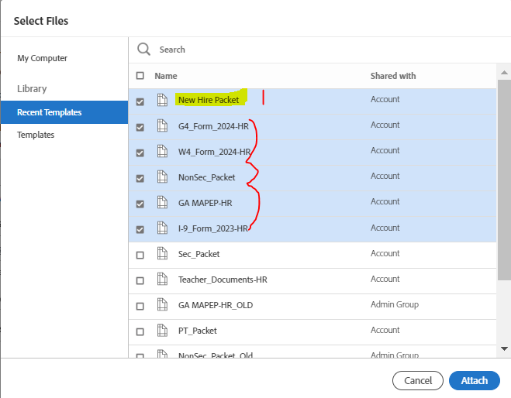

Below is the recommended order of the items for each type of new hire packet:

**Part Time Packet Non-Security Packet Security Packet**

1. New Hire Packet New Hire Packet New Hire Packet
2. Part-Time Position Non-Security Position Security Position
3. GA MAPEP GA MAPEP GA MAPEP
4. I9_Form_2023 I9_Form_2023 I9_Form_2023
5. W4_Form_2024 W4_Form_2024 W4_Form_2024
6. G4_Form_2024 G4_Form_2024 G4_Form_2024
7. Teachers Document (If needed)

**Note:**

If you did not select the items in the correct order, you can reposition them by hovering your mouse over the form you want to move, hold down the left button on your mouse, and then drag the form to the correct position in the list.

You can also click the “x” to the right-hand side of the documents to delete them from the selection and restart the selection process by clicking the “Add Files” link.



Also, we have modified the system options to allow you to customize the document name to go to the applicant before you send it out for signature.  As you can see above, I added “_ApplicantName” to the name so the document will be sent as “**New Hire Packet_ApplicantLastName**”.   I would recommend adding the applicant’s last name so you can easily identify the document when it comes back to you for your signature.

After you have selected the files to send and modified the Packet name, you should click on the Next button.

Then you should click on the blue “SEND” button in the bottom right-hand corner of the page. This will guide you to the Pre-fill fields that you must enter before sending the document to the applicant.

Below are the Prefill fields that you must complete before sending the packet to the applicant:

Once you complete the entry of all the required fields (these are designated with the red asterisk), you will then be prompted with the “Click to Send” button at the bottom of the screen.

You will need to click on this button to send the new hire packet to the applicant.

**Applicant having a issue opening the new hire packet?**

We had a user report that when they clicked on the link, the document did not come up for them to sign. The screen shot of what they received is below:

If your applicant receives this complaint, we suggest three possible solutions.

* 1. If the applicant has anti-virus software running on their personal computer, suggest that they shut down that software and then attempt to sign the document.
  2. The user can use their cell phone to open and sign the document. They can also use their photo feature of their phone to take images of their documents.
  3. Have the applicant come to your office and use a computer to access their email, open and sign the document.

# **Managing your New Hire Packets**

To manage the new hire packets you have in process, you should select the “Manage” tab at the top of the Home page. The below screen will be displayed.

On the left-hand side are a series of folders.

1. **In progress** – these are the new hire packets you have sent to applicants for their review and signature. You will see their email address in the “RECIPIENTS” column. The applicants will receive a system reminder every 24 hours until they complete the application and submit it back to you for final review and signature.

NOTE: You have 14 days to complete **all the processing/signatures** of the packet before it will automatically close and move to the “Expired” folder on the left-hand side. You **cannot**  reactivate the request once it has expired.

1. **Waiting for You** – these are the new hire packets that have been completed by your applicant and are waiting on you to complete the packet.

When you are ready to work on a packet, you should click on the document and a pane will show on the right-hand side of the screen. When you click on the “View & Sign” button, the packet will open and guide you to the required fields you need to sign. You will need to review all forms thoroughly to ensure everything is complete and make sure all required attachments have been added to the packet. **Do not click the “Click to Sign” button until you have a finished packet. You cannot reopen a closed packet.**

NOTE: You will receive system reminders every other day that you have items waiting for your signature. Keep a close eye on the expiration date. The expiration date can be extended if you need to. You can click on the document and then a pane will show up on the right-hand side (see below). You can click on the edit button and modify the expiration date.

1. **Completed** – This is where all your completed new hire packets will reside. You can download the packets from this folder to attach to your HR ETS PA/New Hire request. These packets **cannot be reopened** once completed.
2. **Canceled** – All Canceled requests will go into this folder. These packets **cannot be reopened** once cancelled.
3. **Expired** – All documents that expire before they are completed will automatically close and go to this folder. These packets **cannot be reopened** once cancelled.

**Need to correct email address errors?**

If you realize you made a mistake on the email addresses used when you sent out the packet for signature, you can change the email addresses after it has been sent.

Open your “In Process” view and click on the agreement you need to change. A box will pop up on the right-hand side that will show the Recipients currently set up for the document selected at the bottom of the box. If you click on the name/email you want to change, a box will display to the left. You will see an option to “Replace Recipient”. Click on this and enter the new email address and a message that will be included in the email to the original recipient letting them know

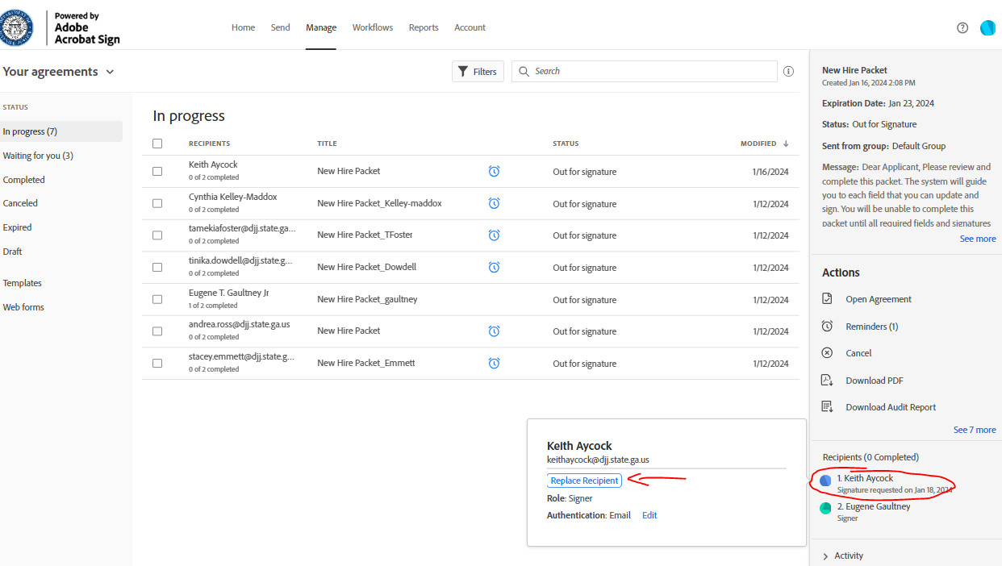

**Need to Cancel a packet sent to an applicant?**

If you need to cancel a packet that was sent to an applicant, you can cancel the packet. It will send a notification of the cancelled request to the applicant.

Under the Manage tab, select “In Progress”. Identify the correct packet you would like to cancel and click on it. On the right-hand side of the screen, a box will pop up. You just need to select “Cancel” option.

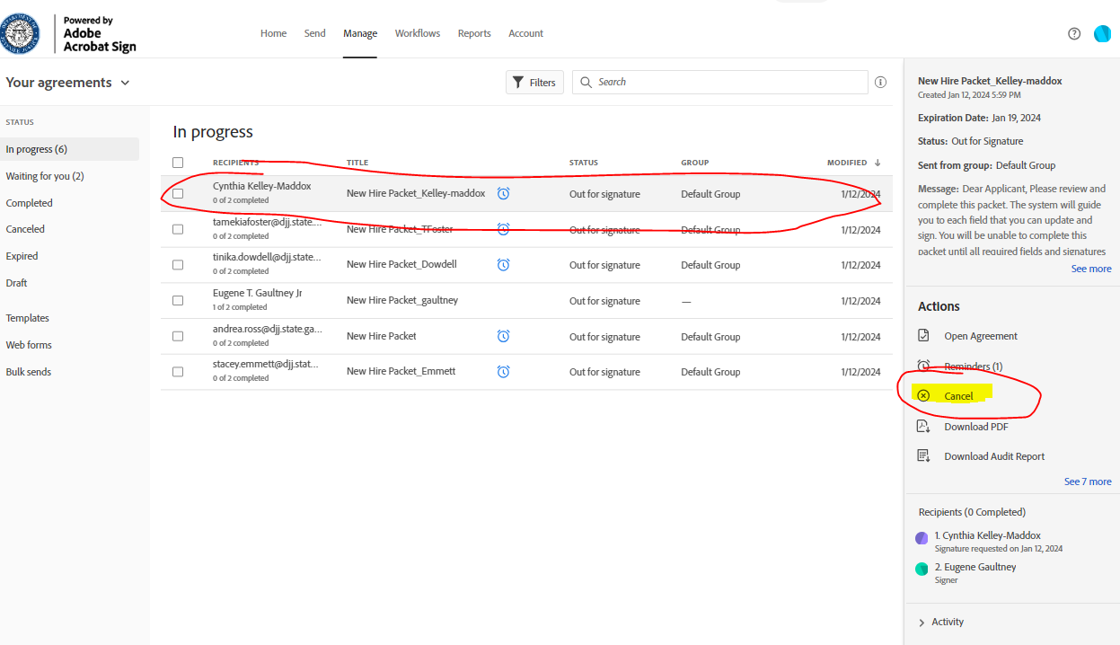

You will then be prompted with the below screen where you can enter a reason for the cancellation. You will also have the option to check a box to send an email notification to the signer that the application has been cancelled.

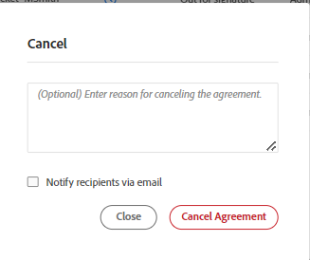

# **Document Downloads**

We cannot allow .pdf attachments to be sent along with email notifications to the applicants due to security concerns over handling applicant PII data.  When the user is working on the packet, they will have the ability to download a blank copy of the packet in a .pdf format.  They can select the “Options” dropdown list in the upper left-hand corner of the system.  There they can select “Download PDF”.

NOTE: This downloaded version will not contain any completed fields on the form.

Another option for an applicant is to download a copy of the document after they submit the completed packet.  They can print pages needed for notary signature or doctor completion by clicking the “download a copy” link on the submission confirmation page (see below screenshot).  They can complete documents needed and send them to their HR contact for them to attach to the packet before signing and completing the packet.

Note:  Once the user closes the confirmation page, they lose the ability to download the document.  They will have to contact their HR contact to obtain a copy of the documents needed.  The applicant will receive an email once the packet has been signed and completed that will contain a link to download the completed document for their records.

**HR Managers Note regarding attachments:**

                HR staff can attach documents to an open/active packet.  Once the applicant submits the packet, the HR manager can download a copy of the packet that contains all completed fields.  HR can print off the pages needed for the applicant, notarize them, and then attach them to the packet before they complete the HR staff signature process.

**IMPORTANT NOTE:**  Once you complete the packet, you CANNOT reopen the document to add attachments.